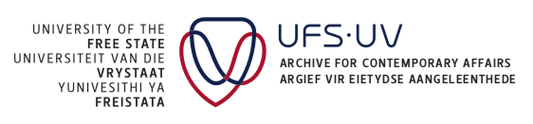

Inventory of the private collection of

PV 329

Contact us
Write to:  Archive for Contemporary Affairs  University of the Free State  P.O. Box 2320  Bloemfontein 9300  South Africa | Visit us:  Archive for Contemporary Affairs  Stef Coetzee Building  Room 109  Academic Avenue South  University of the Free State  205 Nelson Mandela Drive  Park West  Bloemfontein
Telephone:  +27(0)51 401 2418/2646/2225 | Email:  arca@ufs.ac.za
