Chemical Analysis and Evaluation of a Homemade Pest Control Mixture Used by a Local Farmer from Maloti-A-Phofung Municipality of the Afromontane Region in the Free State
A dissertation submitted in accordance with the requirements for the degree

Magister Scientiae
in the
Department of Chemistry
Faculty of Natural and Agricultural Science

at the
University of the Free State

by
Sebotsa Mojabeng Maria

Supervisor

Dr N.F. Molefe

Co-Supervisor
Dr M.F.T. Mosoabisane

November 2022

Declaration

I (Mojabeng Maria Sebotsa) declare that the dissertation submitted by me for the qualification of Magister Scientiae in Chemistry at the University of the Free State is my independent work and has not been previously submitted by me at any time in any other university/faculty. I furthermore cede the copyright of the thesis in favour of the University of the Free State.

Signature Date
 30 Novevember 2022
_____________________________ _________________________ Sebotsa MM

Dedications

To my mother, Mabidi Elizabeth Sebotsa. I'm grateful for everything you've done for me.
Thank you for loving, supporting, guiding, and raising me under the shield and fear of God.

"Praise the Lord. Give thanks to the Lord, for he is good; his love endures forever."
Psalms 106:1

Acknowledgements

I want to extend my sincere thanks to my supervisors, Dr Nomampondomise Flaurette Molefe and Dr. Mafereka Francis Tyson Mosoabisane, for their support, guidance, and constructive advice. I want to acknowledge the assistance of Prof. Philiswa Nomgongo from the University of Johannesburg, Prof. Lisa Buwa- Komoreng from the University of Fort Hare, Dr. Gokul Arun from the University of the Free State and their students. I would like to thank you all for the contributions you made to my study. I'd also like to thank Dr. Anele Mpupa for your helpful advice, unwavering support, insightful suggestions and patience. I acknowledge Dr. Jarmo Kalinski for introducing and teaching me how to use molecular networking and to analyse my data. I sincerely appreciate Mr. Lekgotla Joseph Moshweshwe willingness to allow me to use his homemade pest control. I value the knowledge you offered and your help is greatly appreciated.
I want to acknowledge the University of the Free State, Chemistry department, the University of Johannesburg, the University of Fort Hare, and Rhodes University for allowing me to use their facilities and assistance. To my colleagues from the chemistry department, Qwaqwa campus, I had the great pleasure of working with you, and you made my journey enjoyable. I want to send gratitude to the Afromontane Research Unit, Sasol Inzalo, and the University of the Free State for their financial support.
I am also grateful to my mother and family for their upbringing, tireless dedication and support in every way I take to achieve my dreams and goals. To my friends, many thanks for all the times you supported me, inspired me and stepped in. Without you all, I would not have survived. I would like to thank Almighty God for giving me the opportunity and guidance to achieve my goals and succeed in this part.

Table of Contents
Declaration i
Dedications ii
Acknowledgements iii
List of tables vii
List of figures viii
Abbreviations and symbols xi
Abstract xiv
Introduction, Aims and Objectives 1
1.1 Background 1
1.2 Introduction 1
1.3 Problem statement 4
1.4 Hypothesis 4
1.5 Aim and objectives of the study 4
1.5.1 Objectives 5
1.6 References 6
Literature Review 8
2.1 Introduction 8
2.2 Small-scale farming in South Africa 8
2.3 Pest management methods 10
2.3.1 Biological control 10
2.3.2 Pesticides 11
2.3.2.1 Synthetic pesticides 11
2.3.2 Organic and homemade remedies 16
2.4 Extraction Methods (Liquid-liquid and ultrasonic extraction) 19
2.4.1 Liquid-liquid extraction (LLE) 20
2.4.2 Ultrasonic extraction 21
2.5 Characterisation of the extracts 22
2.5.1 Fourier Transform Infrared Spectrophotometer (FTIR) 22
2.5.2 Ultraviolet-visible spectrophotometry (UV-Vis) 22
2.5.3 Liquid Chromatography-Tandem Mass Spectrometry (LC-MS / MS) 23
2.6 Microbial assay 27
2.7 References 30
Results and Discussion 42
3.1 Introduction 42
3.2 Phytochemical Testing 43
3.3 Ultraviolet-visible spectroscopy (UV-Vis) 45
3.4 Fourier-Transform Infrared Spectroscopy (FTIR) 47
3.4.1 FTIR spectra of sequential extracts 48
3.4.2 FTIR spectra of sonicated extracts 49
3.5 Liquid Chromatography with tandem mass spectrometry (LC-MS/MS) 51
3.6 Biological testing 64
3.6.1 Broth microdilution antibacterial and antifungal results 64
3.6.2 Antifungal results of agar well diffusion method 70
3.7 References 73
Experimental 82
4.1 Introduction 82
4.2 Materials 82
4.2.1 Chemicals 82
4.2.2 Sample collection 82
4.3 Preparation for extraction 83
4.3.1 Liquid-liquid extraction 83
4.3.2 Ultrasonication extraction 85
4.4 Phytochemical test 85
4.4 Spectroscopic analysis 86
4.5.1 Ultraviolent spectrometer (UV-Vis) 86
4.5.2 Fourier-transform infrared spectroscopy (FTIR) 86
4.5.3 Liquid Chromatography with tandem mass spectrometry (LC-MS/MS) 87
4.6 Biological testing 87
4.6.1 Antibacterial activity 87
4.6.2 Antifungal activity 88
4.6.3 Agar well diffusion antifungal Assay 88
4.7 References 90
Conclusion and Future Work 91
5.1 Conclusion 91
5.2 Recommendations 95
5.3 Future Perspectives 96
5.4 References 97
Appendix 98

List of tables

Table 2.1: | Materials that were used as homemade biopesticides and their preparation/ method of application
Table 3.1: | Phytochemical test results of sequential extracts
Table 3.2: | Phytochemical test results of sonicated extracts
Table 3.3: | Antibacterial activity of homemade pest control extracts (MIC in mg/ml)
Table 3.4: | Antifungal activity of homemade pest control extracts (MIC in mg/ml)
Table 5.1: | A summary of LC-MS/MS annotated compounds with the biological properties

List of figures

Figure 1.1: Classification of pesticides based on target organism and example of a homemade mixture
Figure 1.2: Dichlorodiphenyltrichloroethane chemical structure
Figure 1.3: Four main groups of pesticides
Figure 2.1: Chemical structure of 1,1,1-trichloro2,2-bis(p-chlorophenyl)ethane) & Lindane
Figure 2.2: Chemical structure of Glyphosate & Diazinon
Figure 2.3: Chemical structure of Aminocarb & Carbacryl
Figure 2.4: Structures of the natural pyrethrin and the two types of synthetic pyrethroids
Figure 2.4 a: Natural Pyrethrin
Figure 2.4 b: Type ⅰ pyrethroid: Bifenthrin
Figure 2.4 c: Type ⅱ pyrethroid: Esfenvalerate
Figure 2.5: Chemical structures of essential oil constituents
Figure 2.6: Structure of Rotenone
Figure 2.7: Plant oil spray used as insecticide
Figure 2.8 a: Liquid-liquid extraction flowchart
Figure 2.8 b: The phase separation occurs after the two phases have been shaken vigorously Figure 2.9: Ultrasound-assisted extraction
Figure 2.10: Show implementing molecular networking for dereplication in three phases. From collecting MS/MS spectra to visualized molecular networking using Cytoscape.
Figure 2.11: Show how a molecular network is analysed, focusing on different clusters to annotate the compounds present in that group.
Figure 3.1a: UV-Vis spectra of sequential extracts, the homemade pest remedy was sequentially extracted using hexane, chloroform, ethyl acetate, methanol and water.
Figure 3.1 b: UV-Vis spectra of ultrasonic extracts, the homemade pest remedy was extracted with an ultrasonic method using solvents with different polarities.
Figure 3.2: | FTIR spectra of sequence extracts. The graph shows FTIR spectra of hexane, chloroform, ethyl acetate, methanol, and water extracts.
Figure 3.3: | FTIR spectra of sonicated extracts. The graph shows FTIR spectra of hexane, chloroform, ethyl acetate, methanol, and water extracts
Figure 3.4: | Molecular network of Cluster 1
Figure 3.5: | Chemical structure of Undecaethylene glycol
Figure 3.6: | Molecular network of cluster 2
Figure 3.7: | Chemical structure of Imperiline
Figure 3.8: | Chemical structure of Fuziline
Figure 3.9: | Chemical structure of Danthron
Figure 3.10: | Molecular network of cluster 3
Figure 3.11: | Chemical structure of Methyl 4-hydroxy-3-(3-methylbut-2-enyl)benzoate
Figure 3.12: | Chemical structure of N-Methylanthranilic Acid
Figure 3.13: | Molecular network of cluster 4
Figure 3.14: | Chemical structure of Linolenic acid
Figure 3.15: | Chemical structure of Linoleic acid ethyl ester
Figure 3.16: | Chemical structure of Conjugated linoleic acid
Figure 3.17: | Chemical structure of Alpha-tocopherol
Figure 3.18: | Chemical structure of Artemisinin
Figure 3.19: | Chemical structure of Ipravalicard
Figure 3.20: | Molecular network of cluster 5

Figure 3.21: | Chemical structure of Imperatorin
Figure 3.22: | Chemical structure of Derrustone
Figure 2.23: | Agar plates of Fusarium culmorum
Figure 4.1: | Sequence extraction of homemade pest control mixture flow diagram
Figure 4.2: | Homemade pest control extraction process
Figure 4.3: | Extraction of homemade pest control using ultrasonication

Abbreviations and symbols

Compounds Name
CLA Conjugated linoleic Acid
DDT Dichlorodiphenyltrichloroethane
PEG Polyethene glycol
O Oxygen
OP Octylphenols
N Nitrogen
S Sulfur

Techniques
FTIR Fourier Transformed Infrared
HPLC High-Performance Liquid Chromatography
LC-MS/MS Liquid Chromatography with Tandem Mass Spectrometry
LLE Liquid-liquid extraction
UV-VIS Ultraviolet-Visible Spectroscopy
UAE Ultrasonic-Assisted Extraction

Solvents and other chemicals
MeCN Acetonitrile
BaCl₂ Barium chloride
CHCl₃ Chloroform

DMSO Dimethyl Sulfoxide
EtOH Ethanol
C₄H₈O₂ Ethyl acetate
FeCl₃ Ferric chloride
CH₂O₂ Formic acid
HCl Hydrochloric acid
H₂SO₄ Sulphuric acid
K₂Hgl₄ Mercuric potassium iodide
CH₃OH Methanol
NaCl Sodium Chloride
PDA Potato Dextrose Agar
INT P-Iodonitrotetrazolium Violet
H₂O Water

Units and symbols

A Absorbance
Σ Alpha
π* Antibonding orbital
π Bonding orbital
℃ Celsius
cm Centimetre
eV electron volt
ν Frequency
g Gram
l Liter
L/min Liter per minute
ml Millimetres
mg/ml Milligrams per Mililiter
m/z Mass-to-charge ratio
µm Micrometer
µs Microsecond
mm Millimeter
µL Microliter
nm Nanometer
n Non-bonding atomic orbital
% Percentage
v Volume

General
ATR Attenuated total reflectance
CID Collision-induced dissociation
GNPS Global Natural Product Social Molecular Networking
MIC Minimum Inhibitory Concentration
MIF Minimum Fungicidal Concentration
TLC Thin-Layer Chromatography

Abstract

The indigenous community of the Afromontane region has developed and adopted strategies for survival to reduce diseases and eliminate ticks and pests on crops at a lower cost. Biopesticides are efficient in eradicating various plant pests, affordable, quickly biodegradable, with multiple mechanisms of action, freely available supplies, and low toxicity to non-target organisms. The phytochemical composition of different plants is thought to be responsible for their various modes of action. Synthetic pesticides are expensive for small-scale farmers in undeveloped regions like the Afromontane region. Investigating agrochemical alternatives will benefit small-scale farmers who cannot access these due to their high cost. This study aims to analyse and evaluate the effectiveness of homemade pest control used by a small-scale farmer in the Afromontane region.

The homemade pest control mixture used by local farmers was collected, then sequentially extracted and sonicated using hexane, chloroform, ethyl acetate, methanol and water. The extracts were screened for active compounds by phytochemical analysis and characterized using ultraviolet-visible (UV-Vis) spectroscopy, Fourier-Transform Infrared Spectroscopy (FTIR), and liquid chromatography-tandem mass spectrometry (LC-MS/MS. Biological testing was used to examine for antibacterial and antifungal activities. Saponins, phenolic compounds, and terpenes were found in all of the extracts after phytochemical analysis of the samples.

Through using FTIR spectroscopy, the functional groups of the extracts were detected while
UV/Vis spectroscopy identified the presence of chromophore at a region of 220-300 nm. LCMS/MS was performed to dereplicate the analyte components with a focus on their collision induced dissociation (CID) spectra. LC-MS/MS and molecular networking enabled annotation of metabolites active in the different extracts of the homemade pesticide. Based on the connectivity of the molecular network, the homemade pest control molecular networking nodes were grouped into five clusters (1–5). Cluster 1 consists of features annotated as flavonoids, cluster 2 corresponds to compounds of the alkaloids and flavonoids, cluster 3 corresponds to amino acids and alkaloids, cluster 4 consists of fatty acids and alkaloids and cluster 5 consists of features annotated as isoflavonoids. The annotated compounds exhibited various characteristics; some were insecticidal, while others showed antimicrobial activities.

The antibacterial and antifungal properties of the sequential and ultrasonic extracts were examined using microdilution. Among the tested extracts, chloroform sequentially and sonicated extracts, methanol sequentially and sonicated extracts showed the best antibacterial activity with the MIC values of 0.09-0.195 mg/ml. The antibacterial activity for sequential chloroform extract showed the best activity against all the bacterial strains, with MIC values ranging between 0.098-0.39 mg/ml. Most of the extracts tested were ineffective against the fungal strains for antimitotic activity. Only a sonicated methanol extract showed the best antifungal activity. The sonicated methanol extract showed good activity (0.39-0.78 mg/ml) against Candida albicans, C. vulgaris and Trichophyton mucoides. In the case of water extracts, no activity was observed in the gram-negative bacteria and antifungal activity.

The growth of Fusarium culmorum was suppressed by the sequence water extract and sonicated hexane extract. The current study's phytochemical and annotated compounds revealed that homemade pest-control bioactive compounds such as saponins, terpenoids, alkaloids, isoflavonoids and amino acids have antimicrobial properties against a variety of pathogens. Overall, the findings indicate that the mixture contains phytoconstituents that are effective against plant pathogens and capable of killing insect pests.

Keywords: Biopesticides, homemade pest control, extraction, bioactive compounds, molecular networking.

1 Introduction, Aims and Objectives

Background
Globally, food security is threatened by insects’ pests. This has led to the use of pesticides by farmer’s food producers to secure their yields from such pests. African countries are experiencing rapid population growth, food insecurity, and poverty, all of which have increased the use of pesticides¹. Furthermore, Africans living in tropical and subtropical climates often experience high temperatures² and moisture favourable for insects’ population growth³. This leads to insects causing a significant increase in grain loss across many regions of a warmer world, and insects are known to damage crops when they feed on them⁴. Hunger and malnutrition affect many areas in Africa, and with the rise in food insecurity, especially in sub-Saharan Africa, increasing food production and the use of pesticides is unavoidable¹.

Introduction
Pesticides are chemical substances or mixtures used to prevent, destroy, or control unwanted species that compete with humans on plants⁵. Pesticides are classified into insecticides, herbicides, fungicides, bactericides, and they can also be classified based on the targeted pest species and the chemical composition of the pesticide⁶. On the other hand, the classification of pesticides based on the targeted pest species is labelled according to target organism or pest⁶, as shown in Figure
1.1.

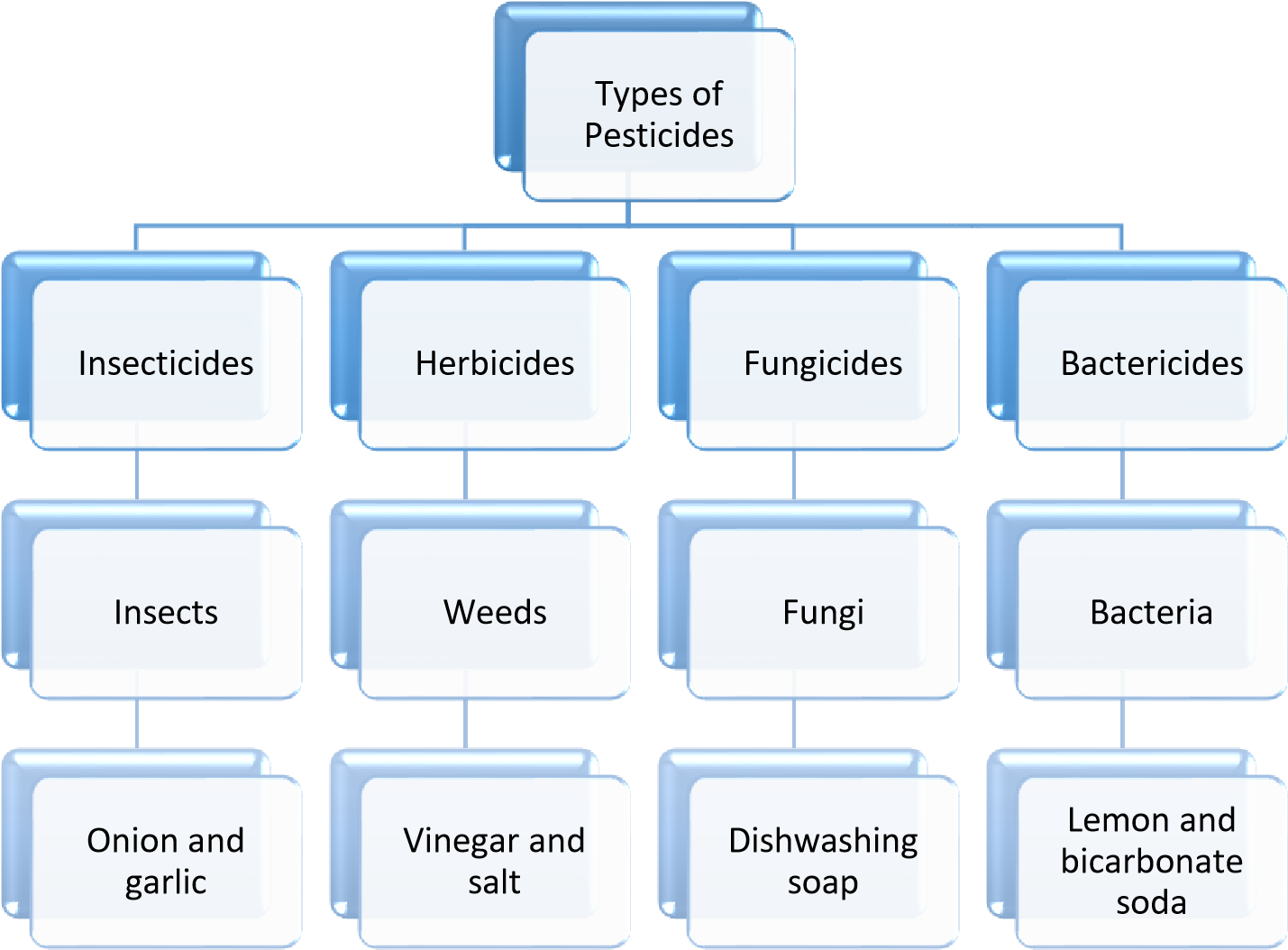
Figure 1.1: Classification of pesticides-based target organism and example of a homemade mixture

Synthetic pesticides were first introduced into the agricultural industry in the early 19th century due to increased pest population and decreasing soil fertility⁷. Before developing synthetic pesticides, sulphur compounds were used as fungicides and arsenicals to control crop insects. Due to the high toxicity, the compounds were replaced by chlorinated pesticides⁸. However, dichlorodiphenyltrichloroethane (DDT), the chemical structure is shown in Figure 1.2, was the first synthetic organic pesticide and synthesized by Zeidler et al. in 1873⁹. This offered advantages such as increased crop yield, cost-effectiveness, insoluble, easy to apply, and mortality of pests¹⁰. Despite its usefulness, the Stockholm Convention has recently debated the possible ban of DDT as a pesticide used for crops due to its environmental impact¹¹.

Figure 1.2: Dichlorodiphenyltrichloroethane Chemical Structure

The chemical classification of pesticides is grouped into four main groups: organochlorines, organophosphorus, carbamates, and pyrethrin¹², shown in Figure 1.3. Organochlorines are organic compounds with five or more chlorine atoms attached to their chemical structure and are synthetic pesticides. DDT, lindane, endosulfan, aldrin, dieldrin and chlordane are examples of organochlorine pesticides¹³. In addition, organophosphorus insecticides have a phosphate group on their chemical structure¹⁴. However, organophosphorus readily decomposes, but they are toxic to both vertebrates and invertebrates. Common examples of this group include parathion, malathion, diazinon and glyphosate¹⁵. On the other hand, the carbamates group is derived from carbamic acid and has carbaryl, carbofuran, and aminocarb⁹. Finally, pyrethroids are synthetic pesticides that modify the structures of the pyrethrin, and they have a rapid photochemical degradation and low acute toxicity against mammals¹⁶. Biopesticides, which are naturally occurring pesticides derived from animals, plants and bacteria, are categorised into microbial, biochemical, or plant-incorporated pesticides based on the active ingredient used¹⁷. Bio-pesticides are advantageous as they are less toxic, degradable, targeted against pests, and cheaper¹⁸.

Figure 1.3: Four main groups of pesticides

Organochlorines
DDT, lindane, endosulfan, aldrin,
dieldrin and chlordane
Organophosphorus
Parathion, malathion, diazinon and
glyphosate
Carbamates
Carbaryl, carbofuran and aminocarb
Pyrethroids
Deltamethrin, cyphenothrin, fenvalerate
Pesticides

There is growing evidence that some of these chemicals may cause harm to humans and other forms of life and cause undesirable environmental effects¹⁹. Almost every living matter on earth could be polluted by organochlorine compounds, including the lakes, oceans, fish that live in the oceans and birds that feed on fish²⁰. The DDT does not degrade rapidly due to its half-life of 2-15 years. Hence, it is not safe to be used for agricultural purposes²¹. Mendelssohn²² stated that during the incorrect application of monocrotophos, organophosphorus insecticide was used to control voles in Israeli. Hundreds of kites, eagles, vultures, and owls were killed by the poisoned voles as they fed on them. Therefore, the global scientific community demanded more organic solutions in developing pesticides. Although various studies have widely been focused on the development of organic pesticides, not much research has been reported on organic homemade pest management remedies²³. Therefore, this study investigates a homemade pesticide utilised by one of the smallscale farmers at the Maloti-A-Phofung municipality in the mountainous Eastern Free State region.

Problem statement
Toxic pesticides do more than kill the pests they target. Exposure to pesticides causes many severe illnesses and diseases to humans and animals. By reducing chemical fertilisers and pesticides, soil pollution can be prevented. Not only do they pollute the soil, but they also damage the plants. Therefore, instead of these harmful toxins, farmers developed use of natural ingredients. Crop production in the Maloti region will increase when crop damages are minimized. Investigating alternatives to agrochemicals is beneficial to small-scale farmers who cannot access these due to their high cost but vital for reducing the harm done to the global environment. Indigenous or traditional knowledge and resources provide a practical way to optimise application free or with low costs. Continued study on allelochemicals can open doorways for the invention of developing new low price and environmentally friendly biopesticides.

There is less to no attention given to innovative and indigenous remedies developed by small scale farmers in solving the pest problem. Deep scientific merit for these remedies is lacking due to less attention given to them. According to our knowledge, this is the first study to attend and document the chemical composition, effective pest control and other biological activites posed by a homemade pest control mixture developed by a small farmer in the Afromontane region of the Free State province.

1.4 Hypothesis
The plant phytochemical constituents in the home-made pest management remedy make it efficient against plant diseases and insect pests.

1.5 Aim and objectives of the study
The overall aim of this study is to validate potential indigenous alternatives to agrochemicals used as pesticides, which, due to high costs, are unavailable for small-scale farmers in the Afromontane region.

1.5.1 Objectives
Collection of the mixture from Ntate Moshweshwe, Hasethunya village
- Extract the homemade pest management remedies using sequential and ultra-sonication extraction methods
- Characterize the extracts using FTIR, UV-Vis, and LC-MS/MS
- Identify active compounds of the homemade pesticide for pesticidal activity
- Analyse the biological activity of the homemade pest control mixture supplied by the farmer

1.6 Outline of the dissertation
This manuscript comprises of five chapters
Chapter 1: Background and objectives
Chapter 2: Literature review
Chapter 3: Results and discussion
Chapter 4: Experimental
Chapter 5: Conclusion

1.6 References
- Saud AL-Ahmadi, M. Pesticides, anthropogenic activities, and the health of our environment safety. in Pesticides - Use and Misuse and Their Impact in the Environment 1–13 (2019).
- Lunde, T. M. & Lindtjørn, B. Cattle and climate in Africa: How climate variability has influenced national cattle holdings from 1961-2008. PeerJ. 1, 1–18 (2013).
- Biber-Freudenberger, L., Ziemacki, J., Tonnang, H. E. Z. & Borgemeister, C. Future risks of pest species under changing climatic conditions. PLoS One 11, 1–17 (2016).
- Riegler, M. Insect threats to food security. Science. 361, 846–845 (2018).
- Jensen, H. K., Konradsen, F., Jørs, E., Petersen, J. H. & Dalsgaard, A. Pesticide use and self-reported symptoms of acute pesticide poisoning among aquatic farmers in phnom penh, cambodia. J. Toxicol. 2011, 8 (2010).
- Akashe, M. M., Pawade, U. V & Nikam, A. V. Classification of pesticides: a review. Int. J.
Res. Ayurveda Pharm. 9, 144–150 (2018).
- Bertomeu-Sánchez, J. R. Introduction. Pesticides: past and present. J. Hist. Sci. Technol.
13, 1–27 (2019).
- Garcia, F. P., Ascencio, S. Y., Gaytan, C. J. O., Hernandez, A. C. & Alavarado, P. V. Pesticides: classification, uses and toxicity. Measures of exposure and genotoxic risks. J. Res. Environ. Sci. Toxicol. 1, 2315–5698 (2012).
- Tano, J. Identity, physical and chemical properties of pesticides. in Pesticides in the Modern World - Trends in Pesticides Analysis, 1–18 (2011).
- Burr, S. A. DDT (Dichlorodiphenyltrichloroethane). Encycl. Toxicol. Third Ed. 1, 1141– 1143 (2014).
- Jayaraj, R., Megha, P. & Sreedev, P. Organochlorine pesticides, their toxic effects on living organisms and their fate in the environment. Interdiscip. Toxicol. 9, 90–100 (2016).
- Zhang, Y., Qi, S., Xing, X., Yang, D., Devi, N. L., Qu, C. & Liu, H. X., Zhang, J. Q., & Zeng, F. M. Legacies of organochlorine pesticides (OCPs) in soil of China-a review, and cases in southwest and southeast China. in Environmental Geochemistry: Site Characterization, Data Analysis and Case Histories: Second Edition 543–565 (Elsevier B.V., 2018).
- Barr, D. B. & Buckley, B. In vivo biomarkers and biomonitoring in reproductive and developmental toxicity. in Reproductive and Developmental Toxicology 253–265 (Elsevier Inc., 2011).
- Abdalla, I. I. G. Determination of Pendimethalin in commercial pesticide formulation and its impurity profile using HPLC. (University of Gezira, 2017).
- Soderlund, D. M. Toxicology and mode of action of pyrethroid insecticides. in Hayes’ Handbook of Pesticide Toxicology 2, 1665–1686 (Elsevier Inc., 2010).
- Marrone, P. G. Pesticidal natural products – status and future potential. Pest Manag. Sci. 75, 2325–2340 (2019).
- Essiedu, J. A., Adepoju, F. O. & Ivantsova, M. N. Benefits and limitations in using biopesticides: A review. in AIP Conference Proceedings 2313, 1–7 (2020).
- Igbedioh, S. O. Effects of agricultural pesticides on humans, animals, and higher plants in developing countries. Environ. Heal. 46:4, 37–41 (2010).
- Hurley, P. M., Hill, R. N. & Whiting, R. J. Mode of Carcinogenic action of pesticides inducing thyroid follicular cell tumors in rodents. Environ. Health Perspect. 106, 437–445 (1998).
- Sereda, B. & Meinhardt, H. Insecticide contamination of the water environment in the malaria endemic areas of KwaZulu-Natal (South Africa). (2003).
- Mendelssohn, H. & Paz, U. Mass mortality of birds of prey caused by Azodrin, an organophosphorus insecticide. Biol. Conserv. 11, 163–170 (1977).
- Mfarrej, M. F. B. & Rara, F. M. Competitive, sustainable natural pesticides. Acta Ecol. Sin.
39, 145–151 (2019).

2 Literature Review

2.1 Introduction
Despite a long history of producing crops, small-scale farmers in South Africa face many constraints such as climate change, soil degradation, shortage of farming skills, and challenging economic times¹. Insects, pathogens and weeds have been causing problems for farmers since the start of agriculture². It is estimated that crop pests and diseases reduce about 30% of crop yield. Current literature suggests loss of crops caused by pests is a big issue for agriculture production and threatens food security³. This chapter will discuss different plant materials used as homemade pesticides, extraction methods and characterisation techniques, including the solvents used in plant extracts.

2.2 Small-scale farming in South Africa

South African agriculture comprises subsistence farmers and large commercial (mainly white) farmers in the former homelands⁴. In South Africa, the phrase "small-scale farmer" carries much baggage, produces false impressions, and is frequently considered negatively as small-scale farming is commonly used in conjunction with the type of outdated, “non-productive, non-commercial subsistence agriculture present in parts of the former homeland”⁵.

Organic farming is ideal for small-scale farming since it relies on naturally available mineral inputs⁶. In addition, organic farming is an ecological and environmentally friendly production system that offers Africa and other poorer countries a variety of advantages regarding the economy, the environment, community, and cultures⁶. Small-scale farmers adopt pest management plans depending on their indigenous knowledge, available time, and tools. The
management technique that organic farmers employ is to keep pest insect populations at levels that do not pose a danger to crops⁷.

2.3 Pest management methods
There are various methods that farmers rely on worldwide to manage insect pests. Some commonly used strategies include pesticides⁸, biological control, and natural insecticides (homemade remedies)⁹, which are explained in the following paragraphs.

2.3.1 Biological control
Natural enemies are used in biological control to reduce or eliminate pests. Predators, parasitism, and diseases are examples of natural enemies or biological control agents¹⁰. Natural enemies are used in different ways focused on the target pest, the host, the habitat, and the life cycle of the pest¹¹. Biological control does not leave behind chemical residues, can provide permanent control, and is not costly¹⁰. Importation (classical biological management), augmentation and conservation are the three biological pest strategies¹⁰.

2.3.1.1 Classical biological control
“Classical biological control refers to the introduction of exotic natural enemies for suppressing populations of an invasive pest species”¹². It is a process of renewing interconnections between pests and their natural predators to help ecosystems establish population equilibrium¹³. Classical biological control aims to reduce pest numbers below a harm threshold, not to eliminate them¹⁰. Classical biocontrol solves this problem by identifying herbivores or pathogens and introducing them to control insect pests¹⁰.

2.3.1.2 Augmentation biological control
Augmentation is an effective alternative when natural enemies are not effective enough¹⁴.The biological control methods referred as "augmentation" include irregularly introducing natural enemies, and the released agents must typically be produced commercially¹⁵. According to van Lenteren¹⁶, pests that had evolved resistant to pesticides were initially managed with augmentative biological control. However, it is now used for efficacy and cost reasons comparable to traditional chemical control. Farmers are also encouraged to utilise this type of biological control to lessen the harmful effects of pesticide use on the environment.

2.3.1.3 Conservation biological control
Conservation biological control is a pest management method that manipulates the environment to increase the population of naturally occurring pest enemies. A greater focus has been placed on "conservation biological control” during the past few decades¹⁷ to reduce economic losses due to pests while avoiding pesticides¹⁸. In addition, it is based on the theory that monocultures and excessively simplified farmscapes are connected with insect outbreaks¹⁹.A study was conducted to review the various techniques used in conservation biological control strategies to help preserve the environment's natural bio - diversity in farming and offer organic solutions to pesticides²⁰. This method could help protect the agricultural environment's natural biodiversity and offer organic alternatives to pesticides.

2.3.2 Pesticides
Other farmers use pesticides to control insects and plant pathogens. Chemical pesticides are classified as synthetic and botanical pesticides. Horsak²¹ et al. define a pesticide as a chemical substance used to control or eradicate insects. The phrase "pesticides" refers to chemicals, including insecticides, herbicides, fungicides, biocides, and similar substances²¹.

2.3.2.1 Synthetic pesticides
Depending on the type of pest they control, synthetic pesticides are classified as insecticides, herbicides, or fungicides²². Some of the significant synthetic pesticide groups are (i) Organochlorines, (ii) Organophosphates, (iii) Carbamates (iv) Pyrethroids²³. These are the ones discussed below.
- Organochlorines
Organochlorines pesticides are chlorinated hydrocarbons employed in agriculture and mosquito control from the 1940s to the 1960s²⁴. These substances are classified as persistent organic pollutants because of their long-term biodegradability²⁵. Some examples of Organochlorines are DDT and Lindane in Figure 2.1²⁶. Paul Müller discovered that DDT (1, 1, 1-trichloro2, 2-bis (p-chlorophenyl) ethane) is very toxic to insects and works faster. It is widely used because it is cheap and easy to produce in large quantities²⁷. Organochlorine pesticides were previously effective in controlling insects²⁸. Using these substances boosts crop production, enhances product quality, and lowers the risk of illness from insects. However, due of their persistence and environmental toxic effects, they are prohibited in the majority of nations²⁹.

b)
a)
Figure 2.1: Chemical structure of 1,1,1-trichloro2,2-bis(p-chlorophenyl) ethane) (a) & Lindane (b)²⁶

- Organophosphates (OP)
Organophosphates (phosphorus-containing compounds) were discovered in 1938³⁰. Organophosphates are distinguished by a phosphorus(P), phosphoryl (P=O) bond or thiophosphoryl (P=S) bond on their structure³¹. Organophosphates are believed to act by inhibiting cholinesterase enzymes³². Organophosphate is highly toxic to both vertebrates and invertebrates, and these chemicals are used against insects such as fleas, lice, flies, and mosquitoes. The organophosphates degrade more rapidly as they are less persistent in the environment than organochlorines³³. As a result, OP has become commonly used as a pesticide in agriculture because it readily degrades when exposed to sunlight, air, soil, or water³⁴. Figure 2.2²⁶ shows examples of organophosphate insecticides such as diazinon and glyphosate.
a) b)
Figure 2.2: Chemical structure of Glyphosate (a) and Diazinon (b)²⁶

- Carbamates
Pesticides containing carbamates were launched in the 1950s and are widely employed in pest management because their effectiveness³⁵. Carbamates are N-substituted carbamic acid esters³⁶. Carbamates mimic organophosphate by inhibiting cholinesterase enzymes that affect nerve impulse transmission³⁷. Carbaryl and Aminocarb in Figure 2.3²⁶ are some of the most often used carbamates³⁸. Furthermore, aldicarb is another example of carbamates with a short environmental half-life³⁹ and is efficient against insects and nematodes⁴⁰. However, carbamates can be absorbed through inhalation, ingestion, and skin contact⁴¹.

- b)
Figure 2.3: Chemical structure of Aminocarb (a) & Carbacryl (b)³

- Pyrethrum
Pyrethrins are the first class of pyrethroids that were extracted from chrysanthemum flowers⁴².
However, synthetic pyrethroids were manufactured in 1941 to increase activity and persistence⁴³. The presence (type I) or lack (type II) of a cyano group (made with carbon and nitrogen) in the first position coupled to a functional group (called alpha) on the molecule has been used to classify them into two primary groupings and separated into two primary groups⁴³ (Figure 2.4). The Pyrethrum operates faster in the environment and degrades quickly due to heat, light, and air. Pyrethroid are photolytically active and are considered fast acting and poisonous to insects at low doses⁴⁴.
R
O
O

  - Natural Pyrethrin
O
O
C
l
F
F
F

O
O
C
N
O
C
l

  - Type ⅰ pyrethroid: Bifenthrin c) Type ⅱ pyrethroid: Esfenvalerate
Figure 2.4: Natural pyrethrin structures and two different types of synthetic pyrethroid⁴⁵

Merely 0.1 percent of pesticides used on crops reach the targeted pests; the remainder is lost to the soil and may leach into groundwater⁴⁶. However, these agrochemicals do not only kill targeted pests but non-targeted organisms as well⁴⁷. Nevertheless, issues and environmental hazards are manifesting from synthetic pesticides. Humans also become exposed to pesticides by inhaling, swallowing, or skin contact⁴⁸. Thus, great care must be taken to prevent pesticides from entering the environment. As a result, it is advised to consider using biopesticides as a possible alternative to synthetic pesticides. Because biopesticides have a variety of mechanisms of action, they are readily available, easily biodegradable, less expensive, and non-toxic to humans and untargeted species⁴⁹.

2.3.2.2 Botanical pesticides
Botanical insecticides are natural compounds with insecticidal capabilities isolated from plants and utilized as an effective suitable alternative to pesticides⁵⁰. Plant organs such as "barks, leaves, roots, flowers, fruits, seeds, cloves, rhizomes, and stems" are used to make botanical insecticides⁵¹. Additionally, Pyrethrum, neem, rotenone, and other essential oils are among the commercially available botanical insecticides. They also contain ryania, nicotine, and sabadilla but are limitedly used⁵².
(i) Essential oils
For a long time, plant essential oils have been employed for pest control⁵³. The essential oils have a distinct aromatic odor⁵⁴. Plant essential oils have a variety of uses, including luring or repelling insects, shielding the plant from warmth and cold, and releasing substances that serve as defence materials. Also, lipophilic compounds of essential oils are the components that act as toxins and feeding deterrents, and they also deter insect pests from laying eggs⁵⁴. Most essential oils are monoterpene compounds that consist of ten carbon atoms and are often found in a ring or acyclic structure. As shown in figure 2.5⁵⁴, examples of essential oils include limonene, p-cymene, eugenol, methyl eugenol, isoeugenol, and phellandrene. The disadvantage of essential oils is that when given to plants excessively, they can be toxic to plants⁵⁵.

Limonene α phellandren p-cymene.

Eugenol Isoeugenol Menthol

Figure 2.5: Chemical structures of essential oil constituents⁵⁴

(ii) Rotenone
Tropical legumes such as Derris, Lonchocarpus, and Tephrosia contain the natural pesticide rotenone in their roots or rhizomes⁵⁶. Rotenone was extracted by soaking dried roots and stems of Derris elliptica in acetone⁵⁷ and trichloroethylene⁵⁸. Rotenone is unstable in the air and under sunlight. They degrade rapidly in soil and water⁵⁹. Furthermore, they can manage insects’ pests including aphids and certain beetles⁶⁰. Therefore, the mentioned qualities make rotenone a good botanical pesticide as they do not show environmental toxicity.

O
O
O
O
O
H
3
C
H
H
O
H
3
C
C
H
3
H
2
C

Figure 2.6: Structure of Rotenone⁵⁸

Due to the disadvantages of chemical pesticides, biopesticides serve as an alternative. Therefore, biopesticides have an advantage over synthetic ones because they degrade fast when sunlight, air, and moisture are exposed. They are broken down into more minor toxic compounds, less risky to non-target organisms, such as the honey-bees⁶¹. Plant extracts and essential oils are used in different countries to manage fungi, bacteria, and nematodes and work very well under controlled condtions⁶². Herbs are also used to combat pest attacks on crops; for example, Ocimum gratissimum L. (Lamiaceae), or African basil, is a scented used to control insects, repel mosquitoes, and kill worms⁶³.

2.3.2 Organic and homemade remedies
Indigenous knowledge system (IKS) is local knowledge unique to a particular culture. It is a community's information base that aids communication and decision-making. In a specific culture, IKS is the knowledge that local people learn through informal experiments and a firm grasp of the environment⁶⁴. The researchers have been interested in learning more about indigenous peoples' abilities and want to know how indigenous people understand, perceive and interact with the environment. Similarly, to integrate accumulated knowledge among indigenous people so that they can design it in various forms and utilise it to develop appropriate actions that will benefit their environment ⁶⁵.

The following are examples of indigenous knowledge about pest control activities. Farmers from Jharkhand in India used water logging methods to prevent termites⁶⁶. Lal & Verma stated that other small-scale farmers rely on ash as it is good to prevent leaf defoliating, chewing and sucking insects. Other farmers have used plant extracts of whey, aloe barbadensis, Nicotiana tabacum, Azadirachta indica and Sapindus trifoliatus to make a homemade mixture to combat mustard insect infestations. Cow urine can be used alone or combined with Vitex negundo, Ferula asafoetida, or Nicotiana tabacum plants extracts to make efficient pesticides⁶⁷.

Some of the materials listed by Islam & Morshed in Table 2.1⁶⁸ can be utilised to make the homemade bio-pesticides described. The study aimed to examine formulations, applications, and issues with homemade combinations. The researchers⁶⁸ recommended the usage of organic pest management systems because they are environmentally beneficial, affordable, and healthful. Vogl & Vogl-Lukasser reported that some home gardeners use manure from cattle, sheep, horses or hens to maintain soil fertility. Other farmers remove bugs by hand, pull the diseased portion of the plant or the entire plant or use homemade medicines to protect plants from illnesses and insect pests, such as nettle (Urtica dioica) and horsetail (Equisetum sp.) teas, soft soap, and lime⁶⁹.
However, no information was given on scientific analysis of the remedies they used.

Table 2.1: Materials that were used as homemade biopesticides and their preparation or method of application by Islam & Morshed⁵
Materials that were used  as homemade biopesticides | Preparation/ method
Neem or Vasaka leave | For organic pest control, neem and vasaka leaves are often employed. Beetles, aphids, and stem borers are all controlled using this product. Farmers produce a paste out of neem or dry them, mix them with water, and apply them to the affected crops.
Cow manure and cow urine | The most commonly used organic pest management approach is cow dung and urine. It is effective against dangerous mites and the Cheri caterpillar and rice weevil.
Insect repellent plants( onion, garlic and sunflower) | Due to their odour, a farmer can plant onion, garlic, or sunflower in the middle of the major crops or combine these items to repel pests.

Soaps are effective against a variety of plant pests. Soaps are used for soft-bodied arthropods like aphids. Soaps appeal to many individuals because of their ease of use, safety, and selective action. Soaps have several drawbacks, including the requirement to moisten the insect prior to application, the lack of any residual activity, and the potential to harm some plants. A soap insecticide is prepared by mixing one litre of water with 1.5 spoons of liquid soap and spraying directly on the plants' damaged areas. It is usually best to use this mixture in the evenings or early mornings rather than during the hottest part of the day⁷⁰,⁷¹.

Angelica Plata-Rueda1⁷² et al. studied the insecticidal activity of garlic. The fatal and repelling effects of essential garlic oil on T. Molitor larvae, pupae, and adults were evaluated. T. Molitor is killed by essential garlic oil, which is deadly and shows sublethal effects. The mixture can be prepared by blending two garlic cloves to make the sauce with a quart of water and ginger. The mixture should be allowed to settle for at least one night. Then half a cup of vegetable oil is added, and one spoonful of soap and water fills the jar. One litre of water should be sprinkled on the affected plants⁷².

According to Carlos⁷³ et al., plant oils can be derived from different plant organs. They also contain fatty acids and other lipids which have pesticidal activity. Additionally, they contain lipids and fatty acids that have insecticidal properties. The most prevalent fatty acids in plant oils are palmitic, steric linoleic, and oleic. Oil-based pesticides must be administered directly to the insect or mite and have a brief residual impact. Plant oils kill delicate insects such as mites, thrips, and aphids by drying out cell membranes. To make the mixture, oil and water are mixed and used as a spray (Figure 2.7) ⁷³. Certain fungal diseases are usually treated with horticultural and plant oils⁷³.

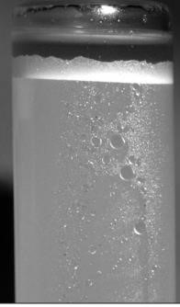
Figure 2.7⁷³: Plant oil spray used as insecticide

Farmers have been using homemade bio-pesticides for years as they are cheaper to produce. Homemade bio-pesticides are obtained directly from nature and are environmentally friendly. As a result, more research is needed to determine homemade biopesticides' chemistry to determine whether their chemical composition will not cause environmental hazards. Consequently, these will make biopesticides readily available in the market, and farmers will adapt to and refrain from highly toxic chemical pesticides.

2.4 Extraction Methods (Liquid-liquid and ultrasonic extraction)
Several researchers extracted pesticidal samples from plants to homemade remedies in various methodes^{74,75}. The commonly used methods include maceration, soxhlet, microwave-assisted, ultrasound-assisted extraction (UAE), supercritical fluid extraction, and other extraction technologies that can extract bioactive chemicals from samples⁷⁴. Only two methods are discussed below because they are perceived as cost-effective.

2.4.1 Liquid-liquid extraction (LLE)
Based on the unique solvency of the solute chemical in two solvents, liquid-liquid extraction (LLE) separates compounds from one solution to another⁷⁶. Solvent extraction advantages are as follows; it consumes less energy, has a higher production capacity, is faster in action, and is easier to operate continuously and automate⁷⁷. However, other processes of LLE are slow. To speed up the process, an electric current, for example, can help mix the two phases efficiently and quickly⁷⁸. Figure 2.7⁷⁹ illustrate the liquid-liquid extraction flowchart and the phase separation occurring after the two phases have been shaken vigorously.

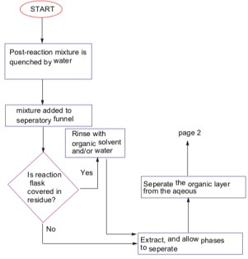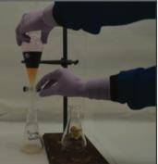

Figure 2.7⁷⁹: Liquid-liquid extraction flowchart and the phase separation occurs after the two phases have been shaken vigorously.

Vasilescu & Medvedovici⁸⁰ stated that the liquid-liquid extraction (LLE) method is employed when extracting pesticide isolation in water and liquid biological samples. Mcpartland⁸¹ et al. extracted, Paclitaxel (a bioactive compound) using the liquid-liquid extraction method, and a significant fraction of Paclitaxel was recovered in dichloromethane and chloroform extracts. A researcher named Jiang⁸² found liquid-liquid extraction to be an effective method to isolate phenol from wastewater.

2.4.2 Ultrasonic extraction
Ultrasonic-assisted extraction (UAE) is an effective and rapid technique. It enhances the diffusion process by facilitating the exchange of substances in plant materials, destroying cell walls and releasing compounds of interest⁸³. UAE has been shown by Corrales⁸⁴ et al. to break down plant tissue and efficiently release active compounds in solvents. UEA has grown in popularity over the previous few decades because of its ease of use, variety, flexibility, and inexpensive investment. Ultrasound extraction for isolating phenolic compounds has increased in popularity over time because it is able to reduce the quantity of solvent and energy utilized⁸⁵. The UAE aims to reduce extraction time, energy, and solvent consumption. It also allows for better mixing, energy transmission, smaller thermal gradients, and lower extraction temperatures⁸⁶. Figure 2.8⁸⁷ show an ultrasonic extraction.
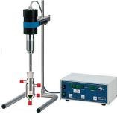
Figure 2.8: Ultrasound-assisted extraction⁸⁷

Hilal⁸⁸ et al. used Ultrasonic-assisted extraction to investigate the thermal stability of phytochemicals. The findings showed that UAE could extract phytochemicals very fast. It is suitable for extracting polyphenol and saponins from plants such as fenugreek leaves. The kind of solvent used dictates the material to extract. Because the final extracted product sometimes contains a residual of a used solvent, it must be less harmful and unreactive with the targeted compound's⁸⁹. A suitable solvent for plant extraction should be a less toxic and non-corrosive chemical that evaporates quickly⁷⁴. To reduce the number of comparable compounds in the desired yield, various solvents may be used sequentially⁸⁵. Several scientists used the following solvents: water, methanol, ethanol, acetone, dichloromethane, and hexane, to carry out sequential plant extractions^{90,75}.

This study used liquid-liquid extraction and Ultrasonic-assisted extraction methods to remove the active compounds in the homemade pesticide.

2.5 Characterization of the extracts
Plant extracts are complex matrix of different compounds⁹¹. It is essential to analyse the extracts using techniques such as thin-layer chromatography (TLC), Fourier transforms infrared spectrophotometer (FTIR), ultraviolet-visible spectrophotometry (UV-`Vis) and Liquid Chromatography-Tandem Mass Spectrometry (LC-MS / MS) to identify the bioactive compounds.
TLC is a fast chromatographic method for determining the number of chemicals in sample ⁹².

2.5.1 Fourier Transform Infrared Spectrophotometer (FTIR)
The functional groups (chemical bonds) present in substances are characterised and identified using a Fourier Transform Infrared Spectrophotometer (FTIR)⁹³. The wavenumber of light absorbed is distinctive of the chemical bond⁹⁴. When an IR is strong or intense, the band has a large dipole and is weaker in fewer polar bonds (disappearing in some completely symmetric bonds)⁹⁵. In the study by Pakkirisamy⁹⁶ et al., FTIR analysis was used to identify phytochemical constituents in black turmeric. Such as N-H, O-H, C=C, C-H, C-O and CH₃ functional groups.

The researchers⁹⁶ stated that FTIR spectroscopy has proven to be a reliable and sensitive approach to determining molecule composition. In addition, the phytochemical results revealed the presence of substances such as carbohydrates, flavonoids, steroids, phenol, alkaloid, tannin, amino acid, terpenoids, and glycosides known to have efficacy against pathogens that cause disease. Sahayaraj ⁹⁴ also used FTIR spectroscopy analyses to reveal different functional groups of the Wedelia biflora plant. Ashokkumar & Ramaswamy⁹⁷ studied the phytochemical screening using FTIR spectroscopic analysis. In their study, the presence of the O-H group suggests that the extract has a more significant potential for preventing the development of microorganisms. FTIR analysis aid in revealing the various characteristic peak in the extracts with various functional chemicals.

2.5.2 Ultraviolet-visible spectrophotometry (UV-Vis)
To detect phytoconstituents, ultraviolet-visible spectrophotometry (UV-Vis) is a simple, costeffective, and quick test^{98,99}. A UV-visible spectrum can also be utilized to determine the compound’s chromophores, aromatic rings, pi bonds, sigma bonds, and lone pair electron contents¹⁰⁰. Aleixandre-Tudo & du Toit used this technique in their study to quantify the phenolic contents of the plant extract¹⁰¹. The range of polyphenol concentrations in the various samples was
44.67 to 334.7 mg GAE/g DW. Phenolic chemicals have hydroxyl in π-conjugated systems. They have a significant absorption of UV light, which is produced by the electronic transitions of phenolic groups in π-type molecular orbitals¹⁰². Dhivya & Kalaichelvi¹⁰³ utilized UV-Vis to identify the active compounds in the Sarcostemma brevistigma's extract. The flavonoid peak was visible in the UV-VIS profile at 254 and 680 nm. Flavonoids and a phenolic metabolite were confirmed by FTIR and UV-VIS spectroscopy.

2.5.3 Liquid Chromatography-Tandem Mass Spectrometry (LC-MS / MS)
LC-MS can identify, quantify unknown compounds, and assist to elucidate different molecules' structure and chemical properties through molecular mass determination¹⁰⁴. LC-MS combines the separation power of High-Performance Liquid Chromatography (HPLC) and the detection power of mass spectrometry¹⁰⁵. A mass spectrometer comprises three major parts: an ion source, a mass analyser, and a detector. A mass analyser resolves the ions either in a time-of-flight tube or electromagnetic field before detectors measure them. LC-MS comprises two phases: reverse and normal. A C18 column is commonly used in reverse-phase liquid chromatography to separate semipolar compounds, such as phenolic acids, flavonoids, glycosylated steroids, alkaloids, and other glycosylated species¹⁰⁶.

Liquid Chromatography-Tandem Mass Spectrometry (LC-MS / MS) was developed for small molecule analysis, providing higher sensitivity and selectivity for microanalysis of multicomponent substances¹⁰⁷. Identifying novel biologically active compounds through testing natural products has been called dereplication¹⁰⁸. Natural product dereplication reduces time, effort, and expense¹⁰⁹. The word "dereplication" is used in screening natural product mixtures¹⁰⁸.

Direct structural information can be obtained by measuring the fragmentation spectrum (MS / MS, tandem first mass spectrometer (MS1), second mass spectrometer (MS2), or multi-round fragmentation). The LC-MS / MS dataset consists of a time series of individual full-scan first spectrometer (MS1) spectra dotted with one or more MS / MS spectra resulting from one or more fragmentation species in the first spectrometer (MS1)¹¹⁰. A helpful application for similarity computation is MS/MS generation by grouping MS/MS spectra into similarity networks to get an overview of the structural diversity of the sample¹¹¹.

The pairwise similarities between consensus LC-MS / MS spectra create a table that can be visualised in molecular networks freeware tools such as Cytoscape (www.cytoscape.org). Each node in the MS / MS network represents a consensus spectrum (ancestor information), and each edge between the two nodes indicates a connection. Cytoscape provides functions for creating edge-weighted constrained layouts for clustering closely related nodes to get an overview of the structure¹¹⁰. Figure 2.11¹¹² illustrate the three crucial steps in molecular networking. From collecting MS/MS spectra to visualised molecular networking using Cytoscape. While Figure 2.12¹¹² show how a molecular network is analysed. As a result, a molecular network is a visual representation of groups that are a chemical similarity¹¹³.

The authors¹¹² wanted to show how effective molecular networking is in supplementing conventional dereplication techniques by organizing MS/MS data based on chemical similarity. Mass spectrometry-based molecular networking was applied to a wide range of marine and terrestrial microbial samples to demonstrate its usefulness as a dereplication tool, showing the dereplication of 58 compounds, including analogues¹¹².

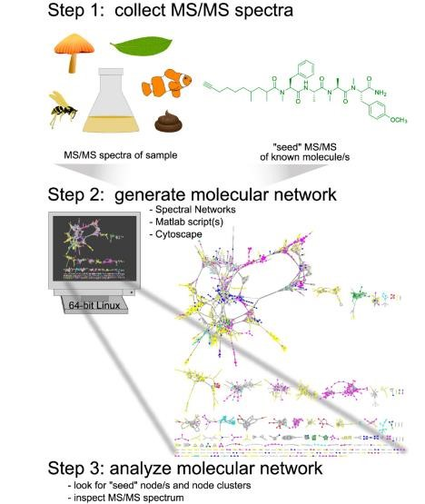

Figure 2.11¹¹²: Show implementing molecular networking for dereplication in three phases¹¹². From collecting
MS/MS spectra to visualised molecular networking using Cytoscape.

In Figure 2.11, step one shows the experimental method from raw material, extraction, and analysis of bacteria and cyanobacteria using LC-MS. The data were converted in step two to mzXML format, a text-based format used to represent mass spectrometry data describing the scan number, precursor mass/charge (m/z), the mass/charge ratio (m/z) and intensity of each ion seen in MS/MS. When all the data had been converted to text mzXML, spectral networks, which include MS-Clustering, were created and then imported into Cytoscape ¹¹⁴. In step three, the Cytoscape was used for molecular network visualisation of the different compounds. In the molecular network, the compounds are grouped based on their connectivity.

In a network, molecular families are clustered because structurally related natural products have comparable MS/MS fragmentation patterns¹¹⁵. In Figure 2:12¹¹², sub-networks were generated in Cytoscape from isolated portions of the larger network to improve node connectivity's visibility. The associated nodes MS/MS spectra at m/z 645.0 and 705.1 corresponded to known lipopeptides in the same chemical family as Carmabin A. One node represented one consensus MS/MS spectrum and was labelled with the precursor mass in the resulting network. An edge reflects relatedness, and edge thickness denotes cosine similarity¹¹².

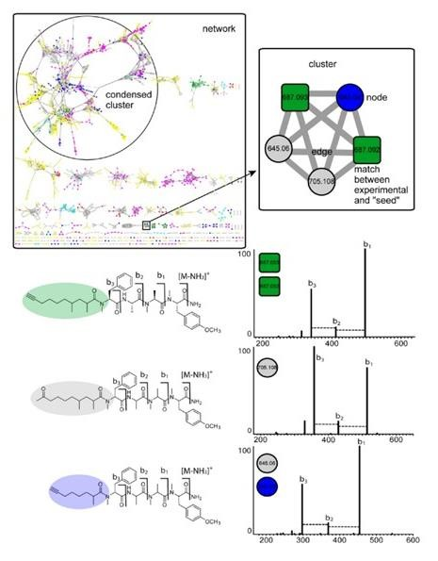
Figure 2.12¹¹²: show how a molecular network is analysed, focusing on different clusters to annotate the compounds present in that group.

The effectiveness of molecular networking compared to other platforms was investigated by Yu ¹¹⁶ et al. The comparison revealed that molecular networking performs better than tools such as mass defect filtering, Agilent MassHunter Metabolite ID, and Agilent Mass Profiler Professional because it was able to identify most metabolites. The molecular networking helped Watrous¹¹¹ et al. to advance their understanding of the spatiotemporal dynamics of metabolite synthesis in living microbial colonies and communities. Moreover, molecular networking enables a quick comparison of mass spectrometry profiles from complex crude extracts for effective chemical dereplication and new metabolite discovery because molecular networks use high-resolution mass spectrometry parent ion fragmentation data (MS/MS)¹¹¹.

The techniques mentioned above were used to analyse the active compounds which might be present in extracts that can be used to manage pests and plant pathogens in my study. For instance, FTIR was used to identify functional groups, and LC-MS/MS was used to annotate different compound structures and spectra.

2.6 Microbial assay
Prior to the development of more complex chemical techniques, biological assays were used to assess the antibacterial activity of antibiotics¹¹⁷. Bioassays are techniques for determining a substance's effectiveness by analysing its pharmacological effects on living organisms (in vivo) or isolated tissues (in vitro) and evaluating these effects with those of a standard¹¹⁸. An extract's or a pure compound's antimicrobial activity can be assessed or screened using a range of scientific techniques. The most used methodologies are the disk-diffusion and broth or agar dilution procedures¹¹⁹.

The minimum inhibitory concentration (MIC) of plant extracts is determined using the broth microdilution method to assess an organism's sensitivity to several antibiotics at once, whereas the zones of inhibition displayed by the extracts are determined using the disk diffusion method¹²⁰. The microdilution method has the advantage of producing a quantitative result (i.e., the MIC). The main drawbacks of the microdilution approach include the time-consuming, physically demanding procedure of generating the antibiotic solutions for each test, the potential for mistakes in making the antibiotic solutions, and the comparatively high number of reagents and space required for each test¹²¹.

The disc diffusion method is a qualitative procedure that involves inoculating an agar plate with a lawn of bacteria at a particular concentration and then covering the surface with paper discs coated with antibiotics¹²¹. The advantages of the disk diffusion method are that it does not need any specialised equipment, the data sets can be easily understood by looking at the disk, and it is the most affordable susceptibility test available. The absence of automated processes or mechanization in the disk test is one of its drawbacks¹²¹.

The reliability and accuracy are impacted by several variables of the agar diffusion method, such as the temperature, the choice of cut-off size for the inhibitory zones and breakpoints, the thickness and consistency of the gel¹²². Elenav¹²³ et al. evaluated the antimicrobial and antifungal properties using the agar diffusion method. Against the studied strains, all oils demonstrated antibacterial and highly potent antifungal activity. The resulting inhibitory zone is contrasted with the control, or agar lacking an antifungal agent and the inhibitory diameter around the disk will rise or decrease in comparison to the control agar¹²⁴.

The Fusarium species are significant plant fungi infections that cause a range of diseases, including scabs, head blight, and crown rot on cereal grains^{125,126}. Fusarium species can be found in a variety of organic substrates, including soil, subterranean and aerial plant parts, plant waste, and other organic substrates¹²⁶. They are also found in water systems all over the world as a result of water structure biofilms¹²⁷. Fusarium is widely distributed because of its adaptability to a variety of environmental factors, its capacity to thrive on a variety of substrates, and its effective dispersal mechanisms¹²⁸. The three Fusarium species that were investigated were Fusarium culmorum, Fusarium oxysporum, and Fusarium verticillioidis.

The fungus Fusarium culmorum targets various areas of a wide variety of grain plants. The virus can induce severe pathological changes as well as numerous phytotoxic and harmful poisons for both humans and animals. Fusarium culmorum thrives as a fungus that grows in soil or as a parasite on crop debris, where it generates macroconidia. Infected seeds can potentially spread the infection throughout the body. The temperature and moisture content of the infection site has an impact on the pathogen's initial establishment on the host surface. Toxin build-up can be decreased by a variety of secondary metabolites generated from plants that have antioxidant properties, such as phenolic compounds and carotenoids¹²⁹.

Fusarium oxysporum creates a white, light blue, purple, or on common media like potato dextrose agar, a mycelial colony with a pale orange colour. Pathogens that enter the soil through the roots of plants can cause soil-borne plant diseases. The pathogen F. Oxysporum is an example of a soilborne pathogen. It has a long history of living in the soil as chlamydospores, enters the roots, spreads throughout the tissues, colonises and metastasises in xylem vessels, and kills plants by causing systemic yellowing and wilting. F. oxysporum causes infections in numerous plant species, including bananas and cabbage¹³⁰.

Fusarium verticillioidis are among the most widespread pathogenic fungi that cause a number of common illnesses in crops, especially maize, which presents a significant challenge to the safety of food^{131,132,133}. F. verticillioidis infection can cause seedling blight, stalk rot, ear rot, and seed rot throughout the growth phase of maize^{134,135,136}. The plants or seeds infected with F. verticillioidis may accumulate fumonisins, a family of mycotoxins categorized as probable carcinogens and linked to several disorders in cattle and humans¹³⁷.

2.7 References
- Khapayi, M & Celliers, P. R. Factors limiting and preventing emerging farmers to progress to commercial agricultural farming in the King William’s area of the Eastern Cape province, South Africa. South Africa J. Agric. Ext. 44, 31–48 (2016).
- Oerke, E. C. Crop losses to pests. J. Agric. Sci. 144, 31–43 (2006).
- Stevenson, P. C. & Belmain, S. R. Tephrosia vogelii : a pesticide of the future for African farming. Boletín SEEA 2, 19–22 (2017).
- Kirsten, J. F. & van Z. J. Defining small-Scale farmers in the South African contex. Agrekon 37, 1–13 (1998).
- Mathinya, V. N., Franke, A. C., van De Ven, G. W. J., & Giller, K. E. Productivity and constraints of small-scale crop farming in the summer rainfall region of South Africa.
Outlook Agric. 51, 139–154 (2022).
- Hine, R., Jules, P., & Twarog, S. Organic agriculture and food security in Africa. (2008).
- Linker, H. M., Orr, D. B. & Barbercheck, M. E. Insect management on organic farms. Org. Prod. Ser. Insect Manag. 1–37 (2009).
- Wilson, C. & Tisdell, C. Why farmers continue to use pesticides despite environmental, health and sustainability costs. Ecol. Econ. 8009, 449–462 (2001).
- El-shafie, H. A. F. Insect pest management in organic farming system. in Multifunctionality and Impacts of Organic and Conventional Agriculture 1–20 (2019).
- Randall, J. M. & Tu, M. Biological control. in Weed Control Methods Handbook, The Nature Conservancy 1–24 (2000).
- Jeffers, A. H. & Chong, J. H. Biological Control Strategies in Integrated Pest Management (IPM) Programs. Clemson Cooperative Extension, Land-Grant Press by Clemson Extension 1–9 (2021). Available at: https://lgpress.clemson.edu/publication/biological-controlstrategies-in-integrated-pest-management-ipm-programs/. (Accessed: 7th June 2022)
- Michaud, J. P. Classical biological control: A critical review of recent programs against citrus pests in Florida. Ann. Entomol. Soc. Am. 95, 531–540 (2002).
- Bellows, T. S. Restoring population balance through natural enemy introductions. Biol. Control 21, 199–205 (2001).
- Perez-Alvarez, R., Nault, B. A. & Poveda, K. Effectiveness of augmentative biological control depends on landscape context. Sci. Rep. 9, 1–15 (2019).
- van Lenteren, J. C. Success in biological control of Arthropods by augmentation of natural enemies. in Biological Control: Measures of Success 77–103 (2000).
- Gurr, G. M., Wratten, S. D. & Altieri, M. A. Ecological engineering: a new direction for agricultural pest management. AFBM J. 1, 28–35 (2004).
- Bianchi, F. J. J. A., Booij, C. J. H. & Tscharntke, T. Sustainable pest regulation in agricultural landscapes: A review on landscape composition, biodiversity and natural pest control. Proc. R. Soc. B Biol. Sci. 273, 1715–1727 (2006).
- Altieri, M. A. The ecological role of biodiversity in agroecosystems. Agric. Ecosyst. Environ. 74, 19–31 (1999).
- El-Wakeil, N., Saleh, M., Gaafar, N., Elbehery, H. Conservation biological control practices. in Biological Control of Pest and Vector Insects 41–69 (2017).
- Horsak, R. D., Bedient, P. B., Hamilton, M. C., Thomas, F. B. Pesticides. in Environmental Forensics 113–165 (1964).
- Grude, A., Donaldson, D., Keily, T., & Wu., L. Pesticides industry sales and usage 2006 and 2007 market estimates. U.S. Environmental Protection Agency (2007).
- Pandya, Y. Pesticides and their applications in agriculture. Asian J. Appl. Sci. Technol. 2, 894–900 (2018).
- Olutona, G. O. & Livingstone, S. T. Detection of organochlorine pesticide (OCPs) residues and trace metals in some selected malt drinks in Nigeria. Beverages 4, 1–11 (2018).
- Jayaraj, R., Megha, P. & Sreedev, P. Organochlorine pesticides, their toxic effects on living organisms and their fate in the environment. Interdiscip. Toxicol. 9, 90–100 (2016).
- Tano, J. Identity, physical and chemical properties of pesticides. in Pesticides in the Modern World - Trends in Pesticides Analysis 1873, 1–18 (2011).
- Hass, H. B., Neher, M. B. & Blickenstaff, R. T. Nitro alkane derivatives related to DDT. Ind. Eng. Chem. 43, 2875–2878 (1951).
- Beceiro-González, E., González-Castro, M. J., Muniategui-Lorenzo, S., López-Mahía, P., Prada-Rodríguez, D. Analytical methodology for the determination of organochlorine pesticides in vegetation. J. AOAC Int. 95, 1291–1310 (2012).
- Chen, Y., Yan, C., Sun, Z., Wang, Y., Tao, S., Shen, G., Xu, T., Zhou, P., Cao, X., Wang, F., Wang, S., Hao, S., Yang, H., Li, H., Zhang, Q. & Liu, W., Zhao, M., Zhang, Z. Organochlorine pesticide ban facilitated reproductive recovery of Chinese striped hamsters. Environ. Sci. Technol. 55, 6140–6149 (2021).
- Jaga, K. & Dharmani, C. Sources of exposure to and public health implications of organophosphate pesticides. Revista Panamericana de Salud Publica/Pan American Journal of Public Health 14, 171–185 (2003).
- Gupta, R. C. Classification and uses of organophosphates and carbamates. in Toxicology of Organophosphate & Carbamate Compounds 5–24 (2006).
- Elbakyan, A. Organophosphate insecticides. in Handbook of Poisoning in Dogs and Cats 199–204 (2008).
- Model, K. J., Sampaio, S. C., Remor, M. B., Mercante, E. & Boas, M. A. V.
Organochlorated and organophosphorus pesticides in the pelotas river sediment. Eng. Agric. 38, 124–134 (2018).
- Chen, S. & Cashman, J. R. Organophosphate exposure: detection and remediation. in Advances in Molecular Toxicology 7, 207–233 (2013).
- Ronald, L. B. Carbamate insecticides. in Classes of Pesticides 1125–1189 (1991).
- Soriano, J. M., Jiménez, B., Font, G. & Moltó, J. C. Analysis of carbamate pesticides and their metabolites in water by solid phase extraction and liquid chromatography: A review. Crit. Rev. Anal. Chem. 31, 19–52 (2001).
- Fukuto, T. R. Mechanism of action of organophosphorus and carbamate insecticides. Environ. Health Perspect. 87, 245–254 (1990).
- Debnath, M. & & Khan, M. S. Health concerns of pesticides. in Pesticide Residue in Foods 103–118 (2017).
- Risher, J. F., Mink, F. L. & Stara, J. F. The toxicologic effects of the carbamate insecticide aldicarb in mammals: A review. Environ. Health Perspect. 72, 267–281 (1987).
- Pandya, Y. Pesticides and Their Applications in Agriculture. Asian J. Appl. Sci. Technol. 2, 894–900 (2018).
- Routt J., Reigart, M. D., James R. & Roberts, M. D. N-Methyl Carbamate insecticides. in Recognition and Management of Pesticide Poisonings 56–62 (1999).
- Urkude, R., Dhurvey, V. & Kochhar, S. Pesticide residues in beverage. in Quality Control in the Beverage Industry 529–560 (Elsevier Inc., 2019).
- Rezende-Teixeira, P., Dusi, R. G., Jimenez, P. C., Espindola, L. S., Costa-Lotufo, L. V. What can we learn from commercial insecticides? Efficacy, toxicity, environmental impacts, and future developments. Environmental Pollution 300, 1-20 (2022)
- Duke, S. O., Kumudini, C. L., Meepagala, K. M., Wedge, D. E., Tabanca, N. & Schrader,
K. K. Natural toxins for use in pest management. Toxins 2, 1943–1962 (2010).
- Werner, I. & Young, T. M. Pyrethroid Insecticides-Exposure and impacts in the aquatic environment. Encycl. Anthr. 5, 119–126 (2017).
- Carriger, J. F., Rand, G. M., Gardinali, P. R., Perry, W. B., Tompkins, M. S., & Fernandez, A. M. Pesticides of potential ecological concern in sediment from south Florida canals: An ecological risk prioritization for aquatic arthropods. Soil Sediment Contam. 15, 21–45 (2006).
- Damalas, C. A. & Eleftherohorinos, I. G. Pesticide exposure, safety issues, and risk assessment indicators. Int. J. Environ. Res. Public Health 8, 1402–1419 (2011).
- Lengai, G. M. W. & Muthomi, J. W. Biopesticides and their role in sustainable agricultural production. J. Biosci. Med. 06, 7–41 (2018).
- Hikal, W. M., Baeshen, R. S. & Said-Al Ahl, H. A. H. Botanical insecticide as simple extractives for pest control. Cogent Biol. 3, 1–17 (2017).
- Lengai, G. M. W., Muthomi, J. W. & Mbega, E. R. Phytochemical activity and role of botanical pesticides in pest management for sustainable agricultural crop production. Sci. African 7, 1–13 (2020).
- Isman, M. B. Botanical insecticides, deterrents and repellents in mordern agriculture and an increasingly regulated world. Annu. Rev. Entomol. 51, 45–66 (2006).
- Isman, M. B. Plant essential oils for pest and disease management. Crop Prot. 19, 603–608 (2000).
- Koul, O., Walia, S. & Dhaliwal, G. S. Essential oils as green pesticides: Potential and constraints. Appl. Entomol. Zool. 32, 437–445 (1997).
- Isman, M. B. Bioinsecticides based on plant essential oils: A short overview. J. Biosci. 75, 179–182 (2020).
- Zhang. P., Qin, D., Chen, J., & Zhang, Z. Plants in the genus Tephrosia: Valuable resources for botanical insecticides. Insects 11, 1–18 (2020).
- Zubairi, S. I., Sarmidi, M. R. & Aziz, R. A. Bio-active constituents of rotenoids resin extracted from Derris elliptica roots: Comparison between local plant extract and SAPHYR (France) cube resin. Adv. Environ. Biol. 8, 904–909 (2014).
- Cabizza, M., Angioni, A., Melis, M., Cabras, M., Tuberoso, C. V. & Cabras, P. Rotenone and Rotenoids in cubè resins, formulations, and residues on olives. J. Agric. Food Chem. 52, 288–293 (2004).
- Dzenda, T., Ayo, J. O., Adelaiye, A. B. & Adaudi, A. O. Ethnomedical and veterinary uses of Tephrosia vogelii Hook F (Fabaceae): A review. Australian Journal of Medical Herbalism 20, 71–80 (2008).
- Hu, M. Y., Zhong, G. H., Sun, Zh. T., Liu, Sh G. H. M., & Liu, X. Q. Insecticidal activities of secondary metabolites of endophytic Pencillium sp. in Derris elliptica Benth. J. Appl. Entomol. 129, 413–417 (2005).
- Sarwar, M. The killer chemicals for control of agriculture insect pests: The botanical insecticides. Int. J. Chem. Biomol. Sci. 1, 123–128 (2015).
- Borges, D. F., Lopes, E. A., Moraes, A. R. F., Soares, M. S., Visôtto, L. E., Oliveira, C. R., & Valente, V. M. M. Formulation of botanicals for the control of plant-pathogens: A review. Crop Prot. 110, 135–140 (2018).
- Benelli, G., Pavela, R., Maggi, F., Wandjou, J. G. N., Fofie, N. G. Y., Koné-Bamba, D., Sagratini, D., Vittori, S., & Caprioli, G. Insecticidal activity of the essential oil and polar extracts from Ocimum gratissimum grown in Ivory Coast: Efficacy on insect pests and vectors and impact on non-target species. Ind. Crops Prod. 132, 377–385 (2019).
- Warren, D. M. & Rajasekaran, B. Putting local to good use. Int. Agric. Dev. 13, 8–10 (1993).
- Kumar, G., Chhetry, N. & Belbahri, L. Indigenous pest and disease management practices in traditional farming systems in north east India. A review. J. Plant Breed. Crop Sci. 1, 28–038 (2009).
- Dey, P. & Sarkar, A. K. Revisiting indigenous farming knowledge of Jharkhand (India) for conservation of natural resources and combating climate change. Indian J. Tradit. Knowl.
10, 71–79 (2011).
- Lal, C. & Verma, L. Use of certain bio-products for insect-pest control. Indian J. Tradit. Knowl. 5, 79–82 (2006).
- Islam, M. S. & Morshed, A. Study on homemade bio-pesticides and organic pest management in organic farming. Int. J. Eng. Sci. 2, 18–25 (2013).
- Vogl, C. R. & Vogl-Lukasser, B. Tradition, dynamics and sustainability of plant species composition and management in home gardens on organic and non-organic small scale farms in Alpine Eastern Tyrol, Austria. Biol. Agric. Hortic. 21, 349–366 (2003).
- Cranshaw, W. S. Insect control: Soaps and detergents. Insect series. https://extension.colostate.edu/docs/pubs/insect/05547.pdf (1996).
- Borden, M. A. & Dale, A. G. Managing plant pests with soaps. EDIS 344, 1–5 (2019).
- Plata-Rueda, A., Martínez, L. C., Santos, M. H. D., Fernandes, F. L., Wilcken, C. F., Soares, M. A., Serrão, J. E., & Zanuncio, J. C. Insecticidal activity of garlic essential oil and their constituents against the mealworm beetle, Tenebrio Molitor Linnaeus (Coleoptera: Tenebrionidae). Sci. Rep. 7, 1–11 (2017).
- Bogran, C. E., Ludwig, S. V. & Metz, B. Using oils as pesticides. Agrilife Extension 1–4 (2006).
- Zhang, Q. W., Lin, L. G. & Ye, W. C. Techniques for extraction and isolation of natural products: A comprehensive review. Chinese Medicine (United Kingdom) 13, 1–26 (2018).
- Parekh, J., Jadeja, D. & Chanda, S. Efficacy of aqueous and methanol extracts of some medicinal plants for potential antibacterial activity. Turkish J. Biol. 29, 203–210 (2005).
- Zhang, J. & Hu, B. Liquid-liquid extraction (LLE). in Separation and Purification Technologies in Biorefineries 61–78 (2013).
- Elgin, J. C. Solvent Extraction. Ind. Eng. Chem. 38, 26–27 (1946).
- Balles, P. J. Solvent extraction in electrostatic field. Ind. Eng. Chem. Process Des. Dev. 20, 564–570 (1981).
- Sandtorv, A. How to be a Successful Organic Chemist. How to be a Successful Organic Chemist 1–53 (2017). Available at: https://status.libretexts.org. (Accessed: 6th June 2022) 80. Vasilescu, M. N. & Medvedovici, A. V. Herbicides. in Ligand Exchange Chromatography 243–260 (2018).
- Mcpartland, T. J. & Patil, R. A., Malone, M. F., Roberts, S. C. Liquid-liquid extraction for recovery of paclitaxel from plant cell culture: Solvent evaluation and use of extractants for partitioning and selectivity. Biotechnol. Prog. 28, 990–997 (2012).
- Jiang, H., Tang, Y. & Guo, Q. X. Separation and recycle of phenol from wastewater by liquid-liquid extraction. Sep. Sci. Technol. 38, 2579–2596 (2003).
- Chemat, F., Rombaut, N., Sicaire, A. G., Meullemiestre, Fabiano-Tixier, A. S., & AbertVian, M. Ultrasound assisted extraction of food and natural products. Mechanisms, techniques, combinations, protocols and applications. A review. Ultrason. - Sonochemistry 34, 540–560 (2017).
- Corrales, M., Toepfl, S., Butz, P. & Knorr, D., Tauscher, B. Extraction of anthocyanins from grape by-products assisted by ultrasonics, high hydrostatic pressure or pulsed electric fields: A comparison. Innov. Food Sci. Emerg. Technol. 9, 85–91 (2008).
- Altemimi, A., Lakhssassi, N., Baharlouei, A., Watson, D. G. & Lightfoot, D. A. Phytochemicals: Extraction, isolation, and identification of bioactive compounds from plant extracts. Plants 6, 1–23 (2017).
- Chemat, F., Tomao, V. & Virot, M. Ultrasound-assisted extraction in food analysis. in Handbook of Food Analysis Instruments 85–103 (2016).
- Giacometti, J., Žauhar, G. & Žuvić, M. Optimization of ultrasonic-assisted extraction of major phenolic compounds from olive leaves (Olea europaea L.) using response surface methodology. Foods 7, 1–14 (2018).
- Isleroglu, H. & Turker, I. Ultrasonic-assisted extraction and thermal stability of phytochemicals from fenugreek leaves. J. Appl. Res. Med. Aromat. Plants 30, 1–12 (2022).
- Ncube, N. S., Afolayan, A. J. & Okoh, A. I. Assessment techniques of antimicrobial properties of natural compounds of plant origin: Current methods and future trends. African J. Biotechnol. 7, 1797–1806 (2008).
- Chaves, J. O., D. et al. Extraction of flavonoids from natural sources using modern techniques. Front. Chem. 8, 1–25 (2020).
- Sasidharan, S., Chen, Y., Saravanan, D., Sundram, K. M., & Latha, L. Y. Extraction, isolation and characterization of bioactive compounds from plant’s extracts. African J. Tradit. Complement. Altern. Med. 8, 1–10 (2011).
- Tuzimski, T. & Sobczyński, J. Application of HPLC-DAD and TLC-DAD after SPE to the quantitative analysis of pesticides in water samples. J. Liq. Chromatogr. Relat. Technol. 32, 1241–1258 (2009).
- Grube, M., Muter, O., Strikauska, S., Gavare, M. & Limane, B. Application of FT-IR spectroscopy for control of the medium composition during the biodegradation of nitro aromatic compounds. J. Ind. Microbiol. Biotechnol. 35, 1545–1549 (2008).
- Sahayaraj, P. A., Gowri, J., Shobana, R. & Prema, A. A., and Dharmalingam, V. Phytochemical screening by FTIR spectroscopic analysis of leaf and stem extracts of wedelia biflora. Int J Nano Corr Sci Engg 2, 322–334 (2015).
- Berthomieu, C. & Hienerwadel, R. Fourier transform infrared (FTIR) spectroscopy.
Photosynth. Res. 101, 157–170 (2009).
- Pakkirisamy, M., Kalakandan, S. K. & Ravichandran, K. Phytochemical screening, GCMS, FT-IR analysis of methanolic extract of Curcuma caesia roxb (black turmeric). Pharmacogn. J. 9, 952–956 (2014).
- Ashokkumar, R. & Ramaswamy, M. Phytochemical screening by FTIR spectroscopic analysis of leaf extracts of selected Indian medicinal plants. Int.J.Curr.Microbiol.App.Sci 3, 395–406 (2014).
- Aysal, P., Ambrus, Á., Lehotay, S. J. & Cannavan, A. Validation of an efficient method for the determination of pesticide residues in fruits and vegetables using ethyl acetate for extraction. J. Environ. Sci. Heal. - Part B Pestic. Food Contam. Agric. Wastes 42, 481–490 (2007).
- Ibrahim, M., Hameed, A. J. & Jalbout, A. Molecular spectroscopic study of River Nile sediment in the greater Cairo region. Appl. Spectrosc. 62, 306–311 (2008).
- Jain, P. K., Soni, A., Jain, P. & Bhawsar, J. Phytochemical analysis of Mentha spicata plant extract using UV-VIS, FTIR and GC/MS technique. J. Chem. Pharm. Res. 8, 1–6 (2016).
- Aleixandre-Tudo, J. L., & du Toit, W. The role of UV-Visible spectroscopy for phenolic compounds quantification in winemaking. in Frontiers and New Trends in the Science of Fermented Food and Beverages 1, 1–21 (2018).
- Guemari, F., Laouini, S. E., Rebiai, A., Bouafia, A., Barhoum, A. Phenolic compounds contain π-conjugated systems with hydroxyl-phenolic groups. They can strongly absorb UV light where π type molecular orbitals electronic transitions of phenolic groups provide the UVvisible spectrum. Appl. Sci. 12, 1–10 (2022).
- Dhivya, S. M. & Kalaichelvi, K. UV-Visible spectroscopic and FTIR analysis of Sarcostemma Brevistigma, Wight and Arn. Int. J. Curr. Pharm. Res. 9, 46–49 (2017).
- Mukherjee, P. K. LC–MS: a rapid technique for understanding the plant metabolite analysis. in Quality Control and Evaluation of Herbal Drugs 459–479 (2019).
- Chromacademy. Mass Spectrometry Fundamental LC-MS Introduction. Crawford
Scientific (2004).
- Xiao, J. F., Zhou, B. & Ressom, H. W. Metabolite identification and quantitation in LCMS/MS-based metabolomics. TrAC - Trends in Analytical Chemistry 32, 1–14 (2012).
- Liu, R., He, P., Li, Z., Li, R. Simultaneous determination of 16 sulfonamides in animal feeds by UHPLC-MS-MS. J. Chromatogr. Sci. 49, 640–644 (2011).
- Ito, T. & Masubuchi, M. Dereplication of microbial extracts and related analytical technologies. J. Antibiot. (Tokyo). 67, 353–360 (2014).
- Hubert, J., Nuzillard, J. M., Renault, J. H. Dereplication strategies in natural product research: How many tools and methodologies behind the same concept? Phytochem. Rev. 16, 55–95 (2017).
- Baars, O. & Perlman, D. H. Small molecule LC-MS/MS fragmentation data analysis and application to Siderophore identification. in Applications from Engineering with MATLAB Concepts 189–212 (2016).
- Watrous, J., Roach, P., Alexandrov, T., Heath, B. S., Yang, J. Y., Kersten, R. D., Van Der Voort, M., Pogliano, K., Gross, H., Raaijmakers, J., M., Moore, B. S., Laskin, J., Bandeira, N., & Dorrestein, P. C. Mass spectral molecular networking of living microbial colonies. Proc. Natl. Acad. Sci. 109, 1743–1752 (2012).
- Yang, J. Y., Sanchez, L. M., Rath, C. M., Liu, X., Boudreau, P. D., Bruns, N., Glukhov, E., Wodtke, A., De Felicio, R., Fenner, A., Wong, W. R., Linington, R. G., Zhang, L., Debonsi, H. M., Gerwick, W. H. & Dorrestein, P. C. Molecular networking as a dereplication strategy. J. Nat. Prod. 76, 1686–1699 (2013).
- Bouslimani, A., Sanchez, L. M., Garg, N. & Dorrestein, P. C. Mass spectrometry of natural products: current, emerging and future technologies. Nat. Prod Rep 31, 1–20 (2015).
- Caesar, L., Kellogg, J. J., Kvalheim, O. M, Cech, R. A., Nadja, B. Integration of biochemometrics and molecular networking to identify bioactive constituents of Ashitaba (Angelica keiskei Koidzumi). Planta Med 84, 721–728 (2018).
- Duy, D. et al. MS / MS networking guided analysis of molecule and gene cluster families.
Proc Natl Acad Sci 110, 1–10 (2013).
- Yu, J. S., Nothias, L. F., Wang, M., Kim, D. H., Dorrestein, P. C. & Kang, K. B., Yoo, H. H. Tandem mass spectrometry molecular networking as a powerful and efficient tool for drug metabolism studies. Anal. Chem. 94, 1456–1464 (2022).
- Eloff, J. N. Avoiding pitfalls in determining antimicrobial activity of plant extracts and publishing the results. BMC Complement. Altern. Med. 19, 1–8 (2019).
- Panuganti, S. J. Principles involved in bioassay by different methods: A mini-review. Res. J. Biol. 3, 1–18 (2015).
- Balouiri, M., Sadiki, M. & Ibnsouda, S. K. Methods for in vitro evaluating antimicrobial activity: A review. J. Pharm. Anal. 6, 71–79 (2016).
- Melorose, J., Perroy, R. & Careas, S. Antimicrobial activity of some medicinal plant extracts against bacteria causing diarrhoea. Statewide Agricultural Land Use Baseline 2015 1, (2015).
- Jorgensen, J. H. & Ferraro, M. J. Antimicrobial susceptibility testing: A review of general principles and contemporary practices. Med. Microbiol. 49, 1749–1755 (2009).
- Bonev, B., Hooper, J., & Judicael, P. Principles of assessing bacterial susceptibility to antibiotics using the agar diffusion method. J. Antimicrob. Chemother. 61, 1295–1301 (2008).
- Serban, E. S., Ionescu, M. & Matinca, D., Maier, C. S. & Bojita, M. T. Screening of the bacterial and antifungal activity of eight volatile essential oils. Farmacia 59, 440–446 (2011).
- Bidaud, A. L., Schwarz, P., Herbreteau, G., Dannaoui, E. Techniques for the assessment of in vitro and in vivo antifungal combinations. J. Fungi 7, 1–16 (2021).
- Nucci, M. & Anaissie, E. Fusarium infections in immunocompromised patients. Clin. Microb. Rev. 20, 695–704 (2007).
- Nelson, P. E., Dignani, M. C. & Anaissie, E. J. Taxonomy, biology, and clinical aspects of Fusarium species. Clin. Microb. Rev. 7, 479–504 (1994).
- Elvers, K. T., Leeming, K. & Moore, C. P. Bacterial-fungal biofilms in flowing water photoprocessing tanks. J. Appl. Microbiol. 84, 607–618 (1998).
- Sreepurna, A. T. & Kindo, A. J. Fusarium: The versatile pathogen. Indian J. Med. Microbiol. 36, 8–17 (2019).
- Kant, P., Reinprecht, Y., Martin, C. J., Islam, R., Pauls, K. P. Disease resistance. in Comprehensive Biotechnology 789–805 (2019).
- Arie, T. Fusarium diseases of cultivated plants, control, diagnosis, and molecular and genetic studies. J. Pestic. Sci. 44, 275–281 (2019).
- Ju, Mi., Zhou, Z., Mu, C., Zhang, X., Gao, J., Liang, Y. & Chen, Ji., Wu, Y., Li, X., Wang, S., Wen, J., Yang, L., Wu, J. Dissecting the genetic architecture of Fusarium verticillioides seed rot resistance in maize by combining QTL mapping and genome-wide association analysis. Sci. Rep. 7, 1–11 (2017).
- Liu, J. X., Cai, Y. N., Jiang, W. Y. & Li, Y. G., Zhang, Q. F., Pan, H. Y. Population structure and genetic diversity of fungi causing rice seedling blight in Northeast China based on microsatellite markers. Plant Dis. 104, 868–874 (2020).
- Mu, C., Gao, J., Zhou, Z., Wang, Z., Sun, X., Zhang, X. & Dong, H., Han, Y., Li, Xi., Wu, Y., Song, Y., Ma, P., Dong, C., Chen, J., Wu, J. Genetic analysis of cob resistance to F. verticillioides: another step towards the protection of maize from ear rot. Theor. Appl.
Genet. 132, 1049–1059 (2019).
- Machado, J. C., Machado, A. Q., Pozza, E. A., Machado, C. F. & Zancan, W. L. A. Inoculum potential of Fusarium verticillioides and performance of maize seeds. Trop. Plant Pathol. 38, 213–217 (2013).
- Stagnati, L., Lanubile, A., Samayoa, L. F., Bragalanti, M., Giorni, P., Busconi, M., Holland, J. B., Marocco, A. A genome wide association study reveals markers and genes associated with resistance to fusarium verticillioides infection of seedlings in a maize diversity panel. G3 Genes, Genomes, Genet. 9, 571–579 (2019).
- Septiani, P., Lanubile, A., Stagnati, L., Busconi, M. & Nelissen, H., Pè, M. E., Dell’acqua, M., Marocco, A. Unravelling the genetic basis of fusarium seedling rot resistance in the magic maize population: Novel targets for breeding. Sci. Rep. 9, 4–13 (2019).
- Rosa Junior, O. F., Dalcin, M. S., Nascimento, Vi. L., Haesbaert, F. M., Ferreira, T. P. S., Fidelis, R. R., Sarmento, R. A. S., Aguiar, R. W. S. & De Oliveira, E. E., Dos Santos, G. R. Fumonisin production by fusarium verticillioides in maize genotypes cultivated in different environments. Toxins (Basel). 11, 1–16 (2019).
3 Results and Discussion

3.1 Introduction
The extraction and the characterisation of homemade pesticide mixture (pest remedy) are discussed in this chapter. The phytochemical and antimicrobial assay tests were done for organic compound classes, followed by antibacterial and antifungal activity screening. The various techniques used include ultraviolet-visible (UV-Vis) spectroscopy, Fourier-Transform Infrared Spectroscopy (FTIR), and liquid chromatography-tandem mass spectrometry (LC-MS/MS). UV-Vis was utilised to identify chromophore groups to validate compound identity. FTIR, on the other hand, was used to identify structural features in the extracts and offer structural information on the suggested chromophores. Furthermore, LC-MS/MS was performed to dereplicate the chromophore analytes constituents focusing on their collision-induced dissociation (CID) spectra. The abovementioned techniques were used to identify the homemade pesticides' chemical composition and the biological activity analysis tests were also done.

The homemade pest control mixture used by local farmers was collected. The mixture contained a variety of plants/herbs, liquid soap, and cow manure, among other components. Before applying the contents to his crops, the farmer ferments the mixture for 14 days. This study did sequential extraction and sonication using hexane, chloroform, ethyl acetate, methanol and water solvents. The extracts were then subjected to phytochemical analysis. The preliminary phytochemical testing was accomplished using standard procedures described by Bargah¹ to identify the various classes of constituents important for bacterial, microbial and pesticidal activity. Initially, the active compounds in the mixture were not known. Hence a phytochemical test was done to identify various classes phytochemical constituents that might be present. The phytochemical screening revealed the presence of the phytochemical groups known to have antimicrobial and insect-repellent properties.

UV-Vis was used to look for any absorption occurring 180-450nm wavelengths. FTIR is a vital tool to indicate the presence or absence of critical functional groups possessed by the active compounds²³. The samples were analysed for FTIR analysis spanning a 650–4000 cm–1 wavenumber range in an attenuated total reflectance (ATR) detector. The presence of various frequencies identified the functional groups of interest. Furthermore, metabolites analysis of organic extract was performed on LC-QTOF-MS/MS. In this study, dereplicated analyte constituents were matched to database matches and literature compound molecular formulas.

Lastly, the samples were tested for antifungal and antibacterial activity using microdilution and agar diffusion methods. The microplate technique determined the minimal inhibitory concentration (MIC) values of homemade pest control extracts. The agar well diffusion method was used to examine the antifungal efficacy of various homemade pest control extracts.

3.2 Phytochemical Testing
In order to separate constituents based on polarity, several solvents with varying polarities were used for the extraction process. The crude extracts were subjected to phytochemical screening to identify various phytochemical constituents. A ferric chloride test was used for phenolic compounds (flavonoids), the sulphuric acid test for terpenoids, a foam test for saponins and the alkaloids were tested using Mayer's test¹. The existence of bioactive metabolites in hexane, chloroform, ethyl acetate, methanol, and water extracts was confirmed using colour reactions testing for particular organic compound classes. Phytochemicals are natural chemicals created by plants⁶ and plants rely on them to defend themselves from other animals, insects, pests and pathogens⁷. Phytochemicals such as flavonoids, tannins, saponins, alkaloids, and terpenoids were found to have the properties to be used as colouring agents, drug flavouring agents, insecticides, pesticides, antibacterial and antifungal products⁸.

Table 3.1 shows the phytochemical test results of sequence extracts. The crude extracts of hexane, chloroform, ethyl acetate, methanol and water tested positive for flavonoids, terpenoids, and saponins except for alkaloids. The results confirm the presence of the phytochemical groups known to have antimicrobial and insect-repellent properties.

Table 3.1: Phytochemical test results of sequence extracts
 | Hexane extract | Chloroform extract | Ethyl acetate extract | Methanol extract | Water extract
Alkaloids | - | - | - | - | -
Flavonoids | + | + | + | + | +
Terpenoids | + | + | + | + | +
Saponins | + | + | + | + | +
Positive +, negative –

These results show that the homemade pest control under study has chemical compounds that can manage pests and pathogens. The farmer uses water to make his homemade remedy. Water extracts also show positive results, which would mean mild conditions and green chemistry for environmental preservation.

Table 3.2 shows the phytochemical test results of sonicated extracts. The phytochemical screening tested positive for flavonoids, terpenoids, and saponins, while alkaloids have shown negative effects again. The absence of alkaloids was consistent with the results of sequence extraction method. The absence of alkaloids could be due to their low concentration in the extracts under study. The phytochemical test results from sequential extraction, and sonicated extracts were similar based on the positive and negative results obtained for the extracts.

Table 3.2: Phytochemical test results of sonicated extracts
 | Hexane extract | Chloroform extract | Ethyl acetate extract | Methanol extract | Water extract
Alkaloids | - | - | - | - | -
Flavonoids | + | + | + | + | +
Terpenoids | + | + | + | + | +
Saponins | + | + | + | + | +
Positive +, negative –

The flavonoids which are present in most plants tested positive; they are feeding repellents, and they are used for insect pest management⁵. They are, therefore, significant indicators of possible pesticidal activity. Lattanzio⁶ et al. stated that phenolic could be used as a natural biological pesticide to ward off intruding pests and plant pathogens. Further research has shown that flavonoids protect plants from biological and chemical challenges such as UV rays, pathogens and insect pests by altering their behaviour, growth, and development^{7,8}.

Hexane, chloroform, ethyl acetate, methanol and water extracts also tested positive for terpenoids. Terpenoids are plant's active compounds vital for biopesticides and novel pesticides, according to a study by Cavoski et al^{. 8}. The phytochemical compounds in the extracts, such as terpenoids, can exhibit insecticidal activities and be used for insect pest management¹⁰. The antiparasitic and deterrent properties of terpenoids were investigated by Plata-Rueda¹¹ et al., who discovered that terpenoids in the plant induced rapid insect mortality.

Furthermore, saponins were present in hexane, chloroform, ethyl acetate, methanol and water extracts. A study has shown that saponins include antifeeding agents, control the growth of many insect species, and can exhibit toxicity against insects¹². However, alkaloids were expected to be present as most.

3.3 Ultraviolet-visible spectroscopy (UV-Vis)
The identified phytochemical compounds were further characterised by UV-Vis spectroscopy. These compounds have chromophore groups that absorb radiation, and due to chromophores, many organic molecules can absorb ultraviolet /visible radiation. UV/Vis absorption can be affected by parameters such as solvent, pH and degree of conjugation¹³. The phytochemicals identified by phytochemical testing above have aromatic, carbonyl, hydroxyl and hydrocarbon functional groups. Carbonyl groups absorb visible light at 280 nm, aromatic compounds absorb light between 230 and 330 nm¹³, while C-H bonds absorb light at 125 nm. These absorption regions will be the wavelengths of interest in this UV-Vis analysis.

At a range of 240-300 nm, a clear broad absorption peak was observed for water, hexane and methanol extracts. In contrast, for ethyl acetate and chloroform extracts, this peak was so small and assumed to be insignificant (see Figure 3.1 (a)). This peak is observed for both sequence and sonicated extracts. It is worth noting that though the peak is very small for ethyl acetate and chloroform extracts under sequence extraction, it is clearly visible under sonicated extraction. Sonication extraction therefore was able to better give higher concentrations of the chromophores than sequence extraction. The broad peaks at about 230 - 290 nm are ascribed to π → π* transition by literature¹³. Aromatic compounds are among compounds going through transitions known as π → π* because they are among the compounds with pi bonds and absorb between 230 and 330 nm. Therefore, some aromatic moieties are present in extracts with notable absorption peaks in the mentioned range.

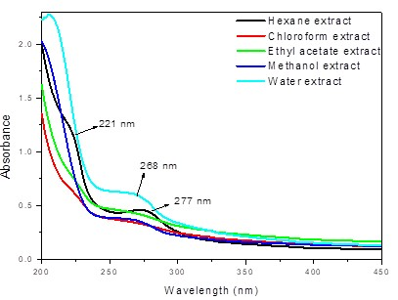
a
)
b)

200
300
400
500
600
700
0
,
5
,
0
1
5
,
1
0
,
2
276
nm
270
nm

Absorbance
Wavelength (nm)
Hexane extract
Chloroform extract
Ethyl acetate extract
Methanol extract
Water extract

Figure 3.1 a): UV-Vis spectra of sequence extracts. The homemade pest remedy was sequentially extracted using hexane, chloroform, ethyl acetate, methanol, and water.
b): UV-Vis spectra of sonicated extracts. The homemade pest remedy was sequentially sonicated using hexane, chloroform, ethyl acetate, methanol, and water.

Furthermore, this means that extracts with higher absorbance will have a higher concentration of the constituents as the Beer-Lambert law states that a solution's absorbance is directly correlated with the concentration of the absorbing substance present in the solution and route length¹⁴.

The vital chromophore shared by several pesticides has the ground-state absorption of π→π* between 250 nm and 300 nm, according to Da Silva¹⁵ et al., which belongs to aromatic groups. Only hexane extracted showed absorption at 221 nm, indicating the presence of a carbonyl group. In the presence of chromophore functional group C=O, Musa¹⁶ et al. reported that the wavelength around 236 nm usually occurs during the transition between nonbonding electrons and antibonding orbital (n → π*). This transition is due to lone pairs of electrons in carbonyl molecular orbitals. Therefore, the homemade pest management remedy has organic chromophores, as shown by 220 nm and 300 nm absorptions for the possible presence of carbonyl and aromatic groups, respectively.

Sonicated extract of chloroform shows a broad absorption peak at 270 nm while hexane, ethyl acetate, methanol and water extracts had the same broad absorption peak at 276 nm. Polar solvents have low absorbance, whereas non-polar solvents, especially chloroform extract, have higher absorbance. Due to the observations, the findings show that hexane, chloroform and methanol sequence extracts have higher constituted concentrations.

Phytochemical test showed the presence of terpenoids in the extracts. Similar observations were reported by Manasa¹⁷ and Haritha¹⁸ et al., who stated the presence of terpenoids with a UV-Vis absorption peak at the 200-350 nm range. Moreover, Upasani ¹⁹et al. reported that the absorption region for flavonoids is between 250 nm and 370 nm. The extracts also exhibited peaks in the same region in this study. The phytochemical test showed saponins' presence. Mutsi et al. reported that saponins absorption is around 280 nm²⁰. The significant bands of saponins appear in the range of 270-320 nm²¹. According to reviewed literature, all the specified phytochemicals have insecticidal properties²².

The UV-Vis spectroscopy absorption region of the extracts was found between 220-300 nm, and it matches with the absorption region of identified phytochemical compounds. The results of the phytochemical test and absorption on the UV/Vis spectra reveal the existence of bioactive compounds with biopesticides potential. Therefore, the results show that the mixture contains phytoconstituents to manage pests and plant diseases.

3.4 Fourier-Transform Infrared Spectroscopy (FTIR)
FTIR spectroscopy (Perkin-Elmer Spectrum 100) was utilised to identify functional groups present in the extracts. The FTIR results of the sequence and sonicated extracts are assigned to various functional groups²³ expected for the chromophores, and their spectra are presented below in Figures (3.2-3.3). The presence of N-H stretching frequency will indicate alkaloids identity, C=C and O-H stretching frequencies for flavonoids. At the same time, for terpenoids and saponins, CH, C=O, and C-O-C will be functional groups of interest²⁴.

3.4.1 FTIR spectra of sequential extracts
The FTIR spectra of sequence extracts are shown in Figure 3.2. There is a broad O-H stretching absorption band at 3305 cm⁻¹ in all the extracts, and highly intense and more prominent for the water and methanol extracts. The intensity for water and methanol extracts is attributed to the solvents water and methanol, which possess in addition the O-H functional group, and it was not easy to completely get rid of the solvent during the drying process. The identification of O-H indicates the presence of flavonoids, as they are mostly phenolic in structure. Stretching vibrations of the aliphatic C-H symmetric and asymmetric stretching vibrations are observed at the 2950-2850 cm¹ range for all the extracts, indicating the presence of hydrocarbons, a characteristic of terpenoids with their subclasses such as saponins.

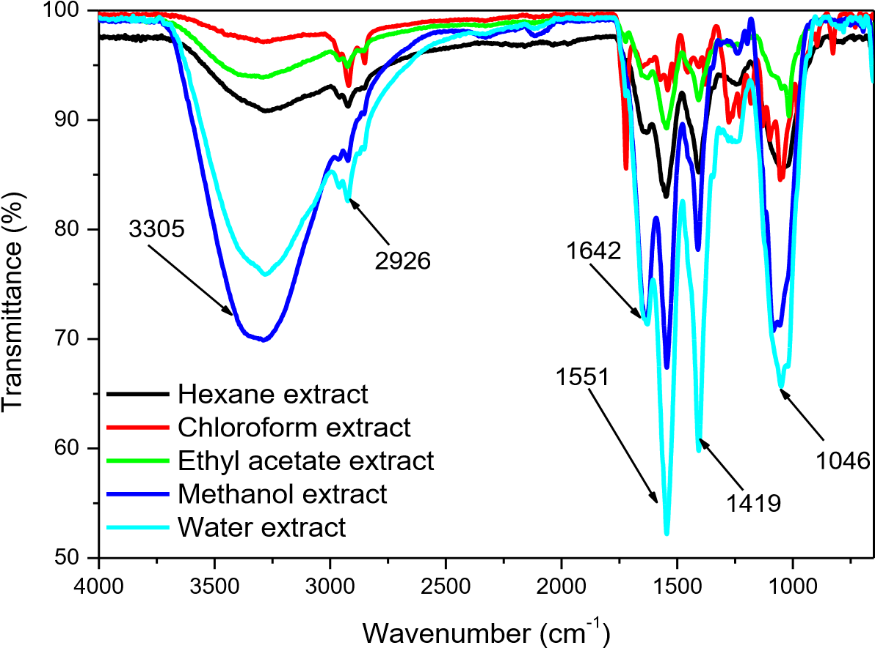

Figure 3.2: FTIR spectra of sequence extracts. The graph shows FTIR spectra of hexane, chloroform, ethyl acetate, methanol, and water extracts.

Two sharp absorption bands around 1500-1650 cm⁻¹ are assigned to the symmetric and asymmetric C=O vibrations, which can be attributed to the oxygenated derivatives of terpenoids, and saponins. Using a water extract as an example, these absorption bands are found at 1551 cm⁻¹ and 1642 cm⁻¹ for the symmetric and asymmetric carbonyl groups, respectively. The broad O-H absorption band around 3305 cm¹ and the sharp C=C-C absorption band around 1419 cm⁻¹ of aromatic ring stretch were found in all the extracts; this confirms the presence of flavonoids. Some flavonoids contain hydrogen atoms adjacent to the hydroxyl groups, double bonds in the benzene rings, and oxo functional groups (C=O) that contribute to their antioxidant activity²⁵. Masek²⁶ et al. found two absorption band around 1634 cm⁻¹ and 3401 cm⁻¹ related to O-H of alcohols and phenols. Similar absorption band were found in figure 3.2, suggesting the presence of flavonoids.

The extracts have all the functional groups that identify the presence of saponins. Saponins have (-OH) at 3429 cm⁻¹, the C-H at 2922 cm⁻¹, C = C at 1619 cm⁻¹, and C=O at 1740 cm^{-1,} the C-O-C at 1034 cm⁻¹ ²⁷. Saponins possess antimicrobial and insecticidal activities²⁸. Phytochemical testing detected the presence of terpenoids. Terpenoids are secondary metabolites in essential oils and are a complex combination of volatile chemicals²⁹. Terpenoids are hydrocarbons (C-H)³⁰ and have insect-deterrent, bactericidal, and herbivore-repellent qualities³¹. Alkaloids are confirmed by O-H, N-H, C=O and C-H stretching groups^{32,33}, and they have been shown to manage insects, herbicides, fungi, and bactericia³⁴. Taking water extract as an example, there is a C-N stretch around 1046 cm⁻¹ for primary amine. Alkaloids, distinguished by heterocyclic nitrogenous molecules with C-N bonds, were detected using FTIR. Although phytochemical studies were unable to identify alkaloids, it appears that FTIR could confirm the presence of alkaloids. Alkaloids have also been shown to manage insects, herbicides, fungi, and bactericia³⁴.

3.4.2 FTIR spectra of sonicated extracts
The FTIR spectra of sonicated extracts are shown in Figure 3.3. The spectra show a broad O-H stretch at 3353 cm⁻¹ and a small C-H stretch absorption band at 2913 cm⁻¹ for hexane, chloroform, ethyl acetate and methanol extract as observed on sequence extraction. The water extract does not show any absorption band in this region. There is a prominent and sharp C=C stretching absorption band around 1648 cm⁻¹ and a medium C=O stretch absorption band at 1648 cm⁻¹ for all the extracts. There is also a strong C-N band at 1017 cm⁻¹ that usually occurs in aromatic amines. The C=C-C around 1407 cm⁻¹ is utilised as an estimate of the characteristic aromatic ring stretch.

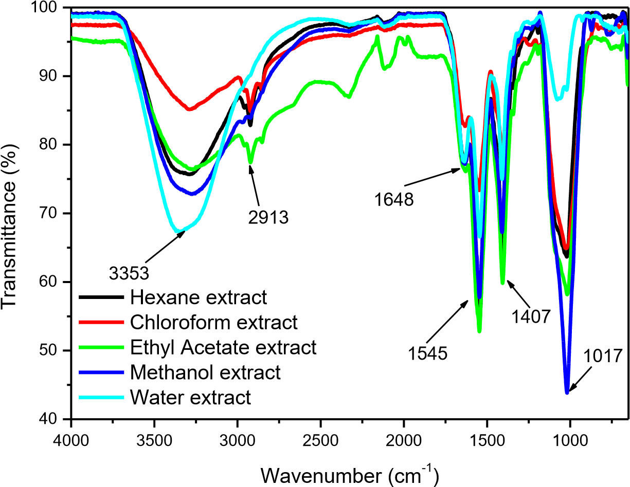
Figure 3.3: FTIR spectra of sonicated extracts. The graph shows FTIR spectra of hexane, chloroform, ethyl acetate, methanol, and water extracts.
In this Figure 3.3, the functional groups identified for sonicated extracts were O-H, C=O, C=C aromatic stretching, C-H, and C-H bending. The oxygenated derivatives of terpenoids, saponins, are responsible for two distinct peaks in the symmetric and asymmetric C=O vibrations at about 1500–1650 cm⁻¹. The symmetric and asymmetric carbonyl group absorption band in all the extracts can be seen at 1545 and 1648 cm⁻¹, respectively. Pharmawati³⁵ et al. identified the peak at 1654 cm¹ as the C=O conjugate. Mondal³⁶ et al. confirmed the saponins by O-H stretch band at 3321 cm⁻¹, aliphatic C-H groups at 2929 cm⁻¹, the absorption band of the C=C bond at 1608 cm⁻¹ and the C=O functional groups of carboxylic acid or ester. Dutta³⁷ et al. used FTIR spectroscopy to validate the terpenoids pyrolysates by detecting strong CH₃ (1377 cm⁻¹) and other CHx (3000-2800 and 1460-1450 cm⁻¹) aliphatic and the aromatic C=C (1560-1650 cm⁻¹) absorption in the Indian resins.

The functional groups identified in both Figure 3.2 and Figure 3.3 are similar, except for the sonicated water extracts that did not have the C-H stretch. It is not clear why the sonicated water extract could not show this band. The FTIR spectra of the two extraction methods confirmed the presence of flavonoids, saponins, terpenoids and alkaloids. Sonication method give sharper and smoother spectra in comparison with sequential method indicating a better extraction method. FTIR analyses aid with the identification of possible functional groups in the extracts. Terpenoids were found by hydrocarbons (C-H), C=O and C-O stretch, saponins by O-H, alkaloids by C-N, N-H and flavonoids by O-H and C=O stretch. The FTIR results also support the findings of phytochemical testing and absorption on the UV/Vis spectra by confirming the existence of bioactive compounds and further suggested the presence of alkaloids which were not identified by phytochemical testing.

3.5 Liquid Chromatography with tandem mass spectrometry (LCMS/MS)
The crude extracts were immersed in methanol for LC-MS/MS analysis, and the data were analysed using a molecular networking approach³⁸. The analysis was performed in reversed-phase and positive mode using an electrospray source (ESI) with collision energies of 30 eV. Original data were turned into an mzXML file and processed with MZmine 2 (ver. 2.34) to create MS1based peak lists with feature-associated MS² spectra⁴¹. The processed MS² data was then submitted to the Global Natural Product Social molecular networking (GNPS; www.gnps.ucsd.edu) platform³⁹, which creates molecular networks based on similarities between fragmentation spectra and performs database searches of repository spectra to identify possible compound matches³⁸. The generated molecular network was displayed in Cytoscape 3.9.0³⁹. Additionally, the homemade pesticide molecular networking nodes are organised into five clusters (1-5) based on the connectivity of the molecular network.

LC-MS/MS was used to replicate the components of the analysed homemade pest remedy extracts based on the collision-induced dissociation spectra. Still, some nodes were left unattached from any networks due to a lack of related substances in the data or poor quality of the associated MS/MS spectra. However, GNPS could annotate some of the nodes in different groups while others are unknown. Moreover, the annotated compounds had different properties. Some had antimicrobial activities, whereas others had insecticidal properties. Examples are laxapur (flavonoid), imperialine (alkaloids), artemisinin, alpha-tocopherol, undecaethylene glycol (flavonoid), imperatorin (flavonoid) and derrustone (flavonoid), with antimicrobial activities^{47, 49, 58,63,70,76,82}. Thus, N-methylanthranilic acid (alkaloid), conjugated linoleic acid, derrustone(flavonoid), iprovalicarb (alkaloids), fuziline(alkaloids), linoleic acid ethyl ester, lipopeptides (alkaloid), imperatorin (flavonoid) and undercaethylene (flavonoid) had insect-repelling activity^{62, 65, 68, 79, 82}.

Cluster 1
Cluster 1 contained 16 nodes, and 9 out of 16 compounds were annotated by library matching, namely P-tert-octylphenol heptaglycol ether, p-tert-octylphenol nonaglycol ether, p-tertoctylphenol hexaglycol ether, p-tert-octylphenol decaglycol ether and undecaethylene glycol. This cluster in Figure 3.4 consists of features annotated as phenols characterised as flavonoids.

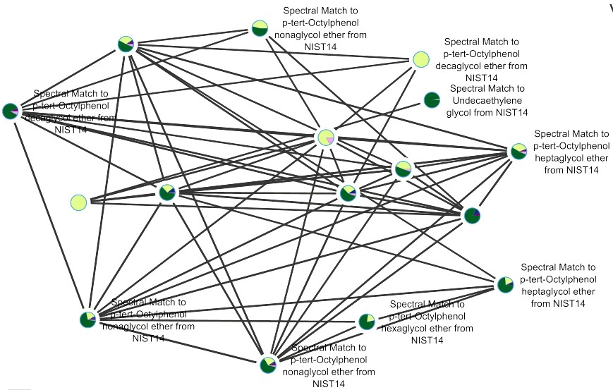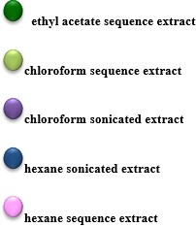

Figure 3.4: Annotated molecular network of cluster 1. Distinct colours on nodes represent different solvent extracts. A dark green=ethyl acetate sequence extract, lime=chloroform sequence extract, lavender=hexane sequence extract, dark blue= hexane sonicated extract, and a dark purple= chloroform sequence extract

In figure 3.4, it shows more dark and light green nodes than any other colours. This means that ethyl acetate and chloroform sonicated extracts could extract most compounds in this cluster. P-tertoctylphenol heptaglycol ether was found in ethyl acetate and chloroform sequence extracts, sonicated chloroform, and hexane extract. In addition, p-tert-octylphenol nonaglycol ether was present in hexane, chloroform and ethyl acetate sequential extractions. Lastly, p-tert-octylphenol decaglycol ether is present in ethyl acetate, chloroform and hexane of sequential extract.

The identified flavonoids in this cluster represent various phenol isomer compounds of the general formula C₆H₄ (OH) C₈H₁₇. They belong to a large family of alkylphenols, including alkyls ranging from C1 to C12, butyl-phenol (C4), nonylphenol (C9) and dodecylphenol (C12)⁴⁰. Alkylphenols are used as a wetting agent for pesticides⁴¹. They are also used as emulsifiers or dispersants in pesticide or herbicide formulations⁴². Ethyl acetate and chloroform sequence extracts, sonicated chloroform, and water extract all contained p-tert-octylphenol heptaglycol ether. Additionally, sequential extractions using hexane, chloroform, and ethyl acetate revealed the presence of p-tert-octylphenol nonaglycol ether. Ethyl acetate, chloroform, and hexane of the sequential extract include p-tert-octylphenol decaglycol ether.

Undecaethylene glycol is also found in this cluster and is known as poly(ethylene glycol)⁴³. Chirife⁴⁴ et al. reported that concentrated polyethene glycol 400 (PEG 400) solutions demonstrate antimicrobial activity against Klebsiella pneumoniae, Pseudomonas aeruginosa, Escherichia coli, and Staphylococcus aureus. Propylene glycol showed bactericidal activity against S. mutans, E. faecalis, and E. coli in Nalawadeet et al⁴⁵. Moreover, this compound was present in sequence ethyl acetate and chloroform extracts, but it is a highly concentrated sequence ethyl acetate extract. The chemical structure of this compound is shown in Figure 3.5.

Figure 3.5: Chemical structure of undecaethylene glycol

Cluster 1, therefore, identified the types of flavonoids present in the homemade mixture.

Cluster 2
Cluster 2 contained 12 nodes. Library matching molecules annotate the nine compounds as imperialine, putative orn, lipopeptides, fuziline, megestrol-17-acetate, danthron and protoporphyrin IX. This cluster in figure 3.6 corresponds to alkaloids compounds.
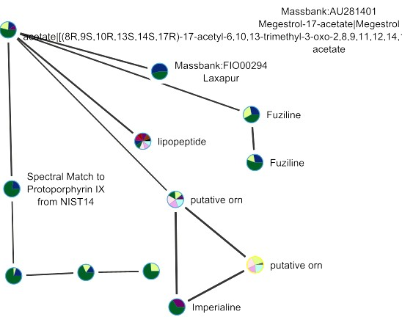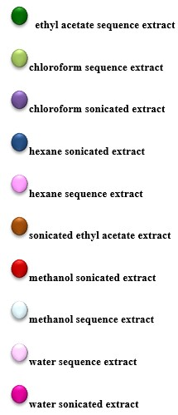
Figure 3.6: Molecular network of cluster 2, distinct colours on nodes represent different solvent extracts. A dark green=ethyl acetate sequence extract, lime= chloroform sequence extract, lavender= hexane sequence extract, dark blue= hexane sonicated extract, a dark purple= chloroform sequence extract, brown= sonicated ethyl acetate extract, maroon= methanol sonicated extract, light pink= water sequence extract, dark pink= water sonicated extract and light blue= methanol sequence extract.

There are more dark and light green nodes, but all the colours are also present in Figure 3.6. In this cluster, all the solvents could extract some of the compounds. However, ethyl acetate, chloroform, and hexane sonicated extracts could extract most compounds. Imperialine was found in ethyl acetate sequence extract and chloroform sonicated extract. Fuziline was present in ethyl acetate, chloroform of sequence extract and sonicated hexane extract. Lipopeptide was present in all the extracts except in the sequential chloroform extract. Danthron was found in ethyl acetate sequence extract and hexane sonicated extract.

Imperialine (C₂₇H₄₃NO₃) is an isosteroid alkaloid, and its chemical structure is shown in Figure 3.7. Steroid alkaloids are nitrogen derivatives of natural steroids with a basic steroid skeleton and one nitrogen atom⁴⁶. Alkaloids are being applied to produce novel antibacterial drugs⁴⁷. Zhou et al. tested the potential of alkaloids against methicillin-resistant Staphylococcus aureus and methicillin-sensitive S. aureus. The antibacterial activity of steroidal alkaloids has been discovered⁴⁸. Additionally, Imperialine was found in ethyl acetate sequence extract and chloroform sonicated extract. About 65 % of the compounds were extracted by ethyl acetate sequence extract, and the remaining was extracted by chloroform sonicated extract.
Figure 3.7: Chemical structure of Imperialine

Fuziline (C₂₄H₃₉NO₇) is a diterpenoid alkaloid isolated from radix preparata of Aconiti lateralis radix preparata⁴⁹. Some diterpene alkaloids are insect repellent⁵⁰. Furthermore, this compound is present in ethyl acetate, chloroform of sequence extract and sonicated hexane extract. This compound is highly concentrated in ethyl acetate sequence extract followed by sonicated hexane extract and chloroform of sequence extract. Figure 3.8 show the chemical structure of fuziline.
Figure 3.8: Chemical structure of Fuziline

Notably, the sharp and prominent C–N stretch band at 1017 and 1046 cm⁻¹as for C–N detected by FTIR allows confirmation of the presence of alkaloids such as imperiline and fuziline that LCMS/MS annotated.

Other biologically active compounds found in this cluster were lipopeptides and danthron though they do not fall under a class of possible pesticides as the chromophores mentioned earlier. Lipopeptide is a biosurfactant nonribosomally synthesised by a large multienzyme complex called the Non-ribosomal Peptide Synthetases⁵¹. These compounds are considered biological pesticides that can be used instead of synthetic insecticides that strongly impact the environment⁵².
Lipopeptides from the genus Bacillus have strong efficacy against insects and parasitic organismis⁵³. It is present in all the extracts except in chloroform sequential extract. The extracts have extracted an equal proportion of this compound.
Danthron (C₁₄H₈O₄) (Laxipur), on the other hand, is an anthraquinone derivative⁵⁴. Danthron is reported to be used as a fungicide in agriculture⁵⁵. Anthraquinone has antibacterial and antifungal activities⁵⁶. Additionally, it was found in ethyl acetate sequence extract and hexane sonicated extract. The two solvents were able to extract the same proportion of these compounds. The chemical structure of the danthron is shown in Figure 3.9.

Figure 3.9⁵⁷: Chemical structure of Danthron

This cluster showed the presence of both alkaloids compounds.

Cluster 3
Cluster 3 contained ten nodes. 7 out of 10 compounds were annotated by library matching, namely 3-methyladenine, 4-hydroxy-3-(3-methylbut-2-enyl) benzoic acid, N-methylanthranilic acid, tributyl phosphate, and 1-[3-methoxy-4-[(2S,3R,4S,5S,6R)-3,4,5-trihydroxy-6[[(2R,3R,4R,5R,6S)-3,4,5-trihydroxy-6-methyloxan-2-yl] oxymethyl] oxan-2-yl] oxyphenyl] ethanone. This cluster in Figure 3.10 consists of features annotated as amino acids.

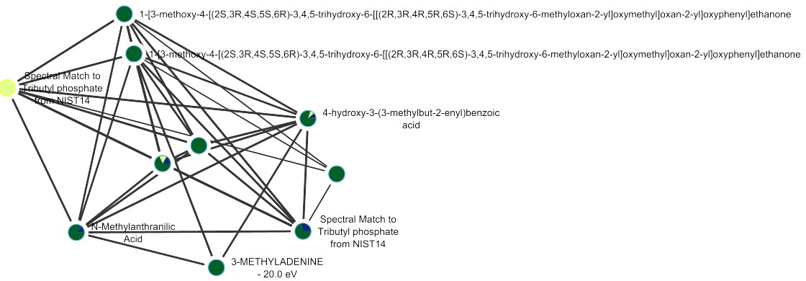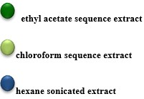

Figure 3.10: Molecular network of cluster 3, different colours on nodes represent different solvent extracts.
Dark green= ethyl acetate sequence extract, lime= chloroform sequence extract, and dark blue= hexane sonicated extract
In this cluster, ethyl acetate sequence extract extracted most compounds hence, figure 3.10 shows more dark green than light green and dark blue node. 4-hydroxy-3-(3-methylbut-2-enyl) benzoate was extracted by ethyl acetate of sequence extract and hexane and chloroform of sonicated extract. NMethylanthranilic acid was found in ethyl acetate of sequence extract and sonicated hexane extract.
4-hydroxy-3-(3-methylbut-2-enyl)benzoate (C₁₃H₁₆O₃) is a prenylated p-hydroxybenzoic acid derivavities⁵⁸. 4-Hydroxy-3-(3-methylbut-2-enyl) benzoic acid has antibacterial properties in the study of Orjala et al⁵⁸. However, it was extracted by ethyl acetate of sequence extract, hexane and chloroform of sonicated extracts. This compound was primarily concentrated in ethyl acetate of sequence extract and a small proportion in sonicated hexane and chloroform extracts. The Chemical structure of Methyl 4-hydroxy-3-(3-methylbut-2-enyl)benzoate is shown in Figure 3.11.
Figure 3.11⁵⁹: Chemical structure of Methyl 4-hydroxy-3-(3-methylbut-2-enyl)benzoate

N-Methylanthranilic acid (C₈H₉NO₂), shown in Figure 3.12, is one of the essential precursors of protein amino acids in alkaloid biosynthesis⁶⁰. According to Yeasmin⁶¹ et al., N-Methylanthranilic acid is also a photoproduct of Azinphos-methyl. In addition, Azinphos-methyl is a widely used organophosphate pesticide⁶². Furthermore, this compound was highly concentrated in ethyl acetate of sequence extract compared to sonicated hexane extract.
Figure 3.12: Chemical structure of N-Methylanthranilic Acid

N-methylanthranilic acid can be categorized as an alkaloid derivative due to the amine (N-H) group connected to its structure. As a result, this cluster demonstrated the existence of alkaloids and compounds with features of amino acids.
Cluster 4
Cluster 4 contains eight nodes. All the compounds were annotated by library matching, namely linolenic acid, linolenic acid ethyl ester, conjugated linoleic acid, alpha-tocopherol, ipravalicard, and (2S)-1-[2-[(3-hydroxy-1-adamantyl) amino]-1-oxoethyl]-2-pyrrolidinecarbonitrile. This cluster consists of fatty acids.
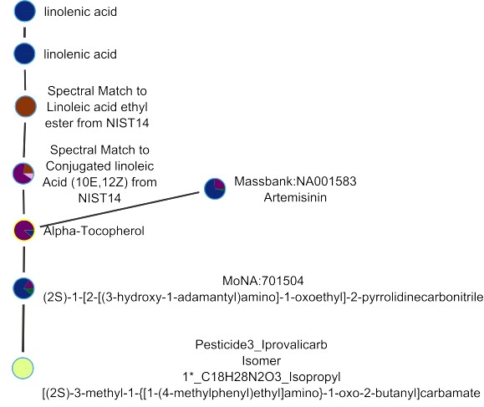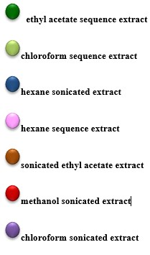
Figure 3.13: Molecular network of cluster 4, distinct colours on nodes represent different solvent extracts. A dark green=ethyl acetate sequence extract, lime= chloroform sequence extract, dark blue= hexane sonicated extract, a dark purple= chloroform sequence extract, brown= sonicated ethyl acetate, and lavender= hexane sequence extract

The molecular network for cluster 4(figure 3.13) shows more dark green nodes; this shows that hexane sonicated extract could extract more compounds in this cluster. Followed by chloroform sonicated extracts and sonicated ethyl acetate. Lastly, hexane sequence extract, chloroform extract and ethyl acetate extract are only shown to extract one compound each. Linolenic acid was extracted by hexane. Linoleic acid ethyl ester was only extracted by ethyl acetate through sonication. Conjugated linoleic acid sequence hexane extract, ethyl acetate, and chloroform sonicated extract. Alpha-tocopherol was found in sonicated chloroform and hexane extracts. Artemisinin sonicated hexane and ethyl acetate extract. It is also extracted by ethyl acetate sequence extract. Iprovalicarb was only extracted by chloroform sequence extract.

Linolenic acid (C₁₈H₃₀O₂) belongs to the essential fatty acid omega-3⁶³. Fatty acids are a vital ingredient for antimicrobial food additives that suppress the growth of unwanted microorganisms⁶⁴. Furthermore, the compound was only extracted by hexane sonicated extract.
Figure 3.14 show the chemical structure of linolenic acid.

Figure 3.14: Chemical structure of Linoleic acid

In the study of Sudha et al., linoleic acid ethyl ester was reported to have nematicide and insectifuge activity⁶⁵. Moreover, the molecule was only extracted by sonicated ethyl acetate extract, and the chemical structure is shown in Figure 3.15.
Figure 3.15: ⁶⁶ Chemical structure of linoleic acid ethyl ester

Conjugated linoleic acid (C₁₈H₃₂O₂) (Figure 3.16) is a fatty acid with two double bonds in its structure⁶⁷. Conjugated linoleic acid showed desirable insecticidal properties such as increased larval mortality, delayed larval growth, inhibitory effect on feeding, and reduced egg survival after maternal ingestion⁶⁸. According to Clements et al., CLA can be an effective biorational pesticide⁶⁸. This compound is highly present in chloroform sonicated extract, followed by sequence hexane extract, sonicated ethyl acetate, and chloroform extracts.

Figure 3.16: Chemical structure of conjugated linoleic acid

Alpha-tocopherol (C₂₉H₅₀O₂) is a lipid-soluble molecule belonging to the vitamin E compounds⁶⁹, and the chemical structure is shown in Figure 3.17. In Andrade⁷⁰ et al., α-tocopherol inhibited S. aureus and E. coli. According to Ghimire⁷¹ et al., a leaf's immense level of α-tocopherol could increase antimicrobial activity. A higher proportion of this compound was found in sonicated chloroform than in sonicated hexane extract.
Figure 3.17: Chemical structure of Alpha-tocopherol

Artemisinin (C₁₅H₂₂O₅) (Figure 3.18) is a natural sesquiterpenes lactone derived from the herb Artemisia annua⁷². The Asteraceae are the primary plants that produce sesquiterpenoids, a large and diverse class of compounds with various functions, including inhibition of microorganisms⁷³. These sesquiterpenoid compounds are crucial to combating increased antibiotic resistance in other plant species and may affect microbial community^{74,75}. In addition, the compound is present in sonicated hexane and chloroform extract. It is also extracted by ethyl acetate sequence extract. The sonicated hexane extract extracted a higher concentration of artemisinin, followed by chloroform sonicated extract, and a small proportion was extracted by ethyl acetate sequence extract.

Figure 3.18: Chemical structure of Artemisinin

Iprovalicarb (C₁₈H₂₈N₂O₃) is an antifungal compound⁷⁶. Iprovaricald has a good toxicology profile. It also has an intense bactericidal action against Plasmopara viticola, Peronospora vicia, Alternaria sp, and Phytophthora sp found in grapes, potatoes, tomatoes, tobacco and vegetables⁷⁶. This compound was only extracted by chloroform sequence extract, and the chemical structure is shown in Figure 3.19.
Figure 3.19: Chemical structure of Ipravalicard

This cluster showed the presence of both fatty acids and alkaloids. Due to substituting an (N-H) group in its structure, ipravalicard can be classed as an alkaloid derivative.

Cluster 5
Cluster five contains five nodes. Two out of five compounds of the extracts were annotated by library matching, namely imperatorin and derrustone. It consists of features annotated as isoflavonoids.
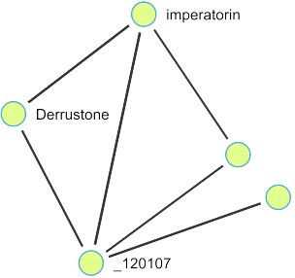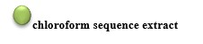
Figure 3.20: Molecular network of cluster 5, a colour on nodes represents different solvents extract. The lime= chloroform sequence extract.

Imperatorin and derrustone were only found in sequence chloroform extract. Imperatorin (C₁₆H₁₄O₄) is a secondary metabolite of the coumarins, specifically the furanocoumarins⁷⁷. Plants containing imperatorin are antibacterial⁷⁸ and insect repellent⁷⁹. Additionally, it was only found in sequence chloroform extract. The chemical structure of imperatorin is shown in Figure 3.21.

Figure 3.21: Chemical structure of Imperatorin
Derrustone (C₁₈H₁₄O₆) (5,7-Dimethoxy-3',4'-methylenedioxyisoflavone) is extracted from the Derris Robusta plant⁸⁰. The biological activity of derrustone has not been reported so far⁸¹. However, isoflavonoids have a wide range of bioactivity. It has insecticidal and antimicrobial properties⁸². In addition, it was only found in sequence chloroform extract. The chemical structure of derrustone is shown in Figure 3.22.
Figure 3.22: Chemical structure of Derrustone
Isoflavonoids are a subclass of flavonoid phenolic chemicals; imperatorin and derrustone are two examples. The active compounds corresponded to features annotated as phenols, alkaloids, fatty acids, and isoflavonoids. Except for alkaloids which are not identified by UV-Vis analysis, the above compounds correspond to the functional groups found with FTIR and UV-Vis analysis. The phytochemical test did not confirm the presence of alkaloids. LC-MS/MS is a technique with higher precision in the identity of chemical compounds. It revealed the presence of alkaloids even though other techniques did not detect them clearly. Liquid chromatography with tandem mass spectrometry (LC-MS-MS) combines the capacity to separate substances using liquid chromatography with the extremely sensitive and selective mass analysis capabilities of triple quadrupole mass spectrometry.
The extraction methods vary considerably, and the sequence extraction method could extract more chemicals. The networks show that ethyl acetate extract, chloroform sequence extract, and sonicated hexane extracted more compounds than other solvents. Sequence extraction is shown to have been the best method in this study than the sonicated method. For sequence extraction, homemade pest control and solvents were stirred for 24 hours, while for sonicated extraction method, it was only sonicated for 15 minutes. The results show that time, solvent and the extraction procedure affect the bioactive compounds.
The results show that the homemade pest control extracts have active compounds that are effective against plant pathogens and could kill insect pests. The properties of the annotated compounds from the literature show that the bioactive compounds in homemade pest control can manage plant pathogens and repel insects. All spectra can be found on GNPS at https://gnps.ucsd.edu/ProteoSAFe/status.jsp?task=97271668ab52445c97ec77623a72efc0.

3.6 Biological testing
This section aims to diversify the possible application of the homemade mixture, not limited only to pesticide effects. Tests and analyses done above suggest that there is a potential to multi-purpose the homemade mixture under this study. Antifungal and antibacterial activities are therefore explored.

3.6.1 Broth microdilution antibacterial and antifungal results
The microplate method determined homemade pest control extracts' minimal inhibitory concentration (MIC) values. To test the antibacterial activity of the extracts, Pseudomonas aeruginosa, Escherichia coli, Klebsiella pneumoniae, Staphylococcus aureus, Staphylococcus epidermidis, Bacillus cereus, Bacillus pumilus, Enterococcus feacalis, Proteus vulgaris, and Shigella flexneri bacterial strains were used. For antifungal screening, Candida albicans, C. vulgaris and Trichophyton mucoides were used as test microorganisms. The microorganisms mentioned above are human pathogens. We used these organisms because human pathogens also use plants as alternative hosts; they were easily accessible, and there are reports about human pathogens contaminating the plants.

In the past few years, there have been increasing reports of infections brought on by eating vegetables infected with human pathogenic microorganisms^{83,84}. One of the potential causes of contamination with such pathogens during vegetable production is the use of organic fertilisers. Plants are additional hosts for many human pathogenic bacteria, including Salmonella enterica serovar Typhimurium, Escherichia coli, and Pseudomonas aeruginosa^{85,86}. For instance, Shigella contamination in plants has been documented, but it is not known whether the bacteria actively invade or multiply there⁸⁷. In vegetable production, there are various ways in which contamination by human pathogenic microorganisms can occur. For example, using contaminated water for irrigation, soil, or direct contact could spread pathogens to the plants⁸⁸.

Table 3.4 summarises the findings of the extracts' general screening for antibacterial activity. Compounds with lower MIC values are more effective antibacterial agents since they need less antibiotic to stop the organism's growth. The extracts were considered highly active (highlighted yellow in table 3.4) with MIC values between 0.098 and 0.78 mg/ml, moderately active
(highlighted blue in table 3.4) at 1.56 mg/ml and poor activity between 3.125 and 12.5 mg/ml.
Table 3.4: Antibacterial activity of homemade pest control extracts (MIC in mg/ml)
Extract |  |  |  | Bacteria
methods and E.  solvents coli  (-) |  | K.  pneumoniae  (-) | P.  aeruginosa  (-) | P. vulgaris  (-) | S. flexneri  (-) | B. cereus  (+) | B.  pumilus  (+) | E. feacalis  (+) | S.  aureus  (+)
Sequential extraction  Chloroform 0.78 |  | 0.78 | 0.78 | 0.78 | 1.56 | 0.39 | 0.39 | 0.195 | 0.098
Hexane | 6.25 | 6.25 | 6.25 | 6.25 | 12.5 | 1.56 | 1.56 | 1.56 | 1.56
Ethyl  acetate | 3.125 | 3.125 | 3.125 | 3.125 | 3.125 | 1.56 | 1.56 | 1.56 | 1.56
Methanol | 1.56 | 1.56 | 1.56 | 1.56 | 6.25 | 3.125 | 0.79 | 0.79 | 0.79
Water | 6.25 | 12.5 | 12.5 | 12.5 | 6.25 | 6.25 | 6.25 | 1.56 | 1.56
Ultrasonic  Chloroform | 0.39 | 0.39 | 0.39 | 0.39 | 0.78 | 0.195 | 0.195 | 0.195 | 0.195
Hexane | 3.125 | 3.125 | 3.125 | 3.125 | 1.56 | 0.78 | 0.78 | 1.56 | 0.39
Ethyl  acetate | 3.125 | 3.125 | 3.125 | 3.125 | 3.125 | 0.78 | 0.78 | 1.56 | 0.78
Methanol | 0.098 | 0.195 | 0.195 | 0.39 | 0.195 | 0.098 | 0.098 | 0.195 | 0.098
Water | 6.25 | 12.5 | 12.5 | 12.5 | 6.25 | 1.56 | 1.56 | 1.56 | 0.78
Neomycin  (control) | 0.39 | 0.78 | 0.39 | 0.78 | 0.39 | 0.78 | 0.39 | 0.78 | 0.39
(-) = Gram negative bacteria and (+) = gram-positive). Highly active = Yellow, moderately active = Blue, and poor activity = No colour

Among the tested extracts, chloroform and methanol showed the best antibacterial activity. The antibacterial activity for sequential chloroform extract showed the best activity against all the bacterial strains, with MIC values ranging between 0.09-0.195 mg/ml except for S. flexneri, which showed moderate inhibition. Chloroform sequence extract has a minimal inhibition of 0.78 mg/ml was observed against E. coli, K. pneumoniae, P. aeruginosa and P. vulgaris. In addition, 0.39 mg/ml was observed against B. cereus and B. pumilus, while 0.195 and 0.098 mg/ml were observed against E. feacalis and S. aureus, respectively.

The best inhibition by the chloroform extracts could be due to bioactive compounds which is in agreement with annotated compounds from molecular networking (cluster 1–cluster 5). From molecular networking, the compounds annotated in chloroform extract were p-tert-octylphenol heptaglycol ether, p-tert-octylphenol nonaglycol ether, p-tert-octylphenol decaglycol ether, undecaethylene glycol, fuziline, imperatorin, iprovalicarb, derrustone which have the antimicrobial properties^{47, 49, 58,63,70,76,82}. Molecular modelling also reveals that the extracts have imperatorin, which has antibacterial⁷⁸ and insect repellent⁷⁹ characteristics. In addition, derrustone is an isoflavonoid, and isoflavones and derivatives have been widely recognised as effective antimicrobial agents⁸². The compounds annotated in sonicated chloroform extract were p-tertoctylphenol heptaglycol ether, imperialine, lipopeptide, methyl 4-hydroxy-3-(3-methylbut-2-enyl) benzoate, conjugated linoleic acid, alpha-tocopherol. Zhou⁴⁸ and co-workers tested the antibacterial activities of these compounds against Staphylococcus aureus. Some isolated compounds, such as steroidal alkaloids, showed good antibacterial activity against the strains. Since chloroform extracts required fewer concentrations to inhibit the growth of the pathogens, this made them more efficient antibacterial agents.

Both sequential and sonicated hexane, ethyl acetate and water detected low activity against gram-negative bacterial strains. Moreover, sequentially extracted hexane and ethyl acetate extracts showed moderate activity, while sonicated hexane and ethyl acetate extracts showed moderate to best activity against gram-positive. In the study of Nuraskin⁸⁹ et al., the growth of the S. mutans bacterium (gram-positive) was inhibited by extracts of n-hexane, ethyl acetate, and methanol from Laban leaves. The results from this study show that hexane, ethyl acetate, and methanol extracts have good activity against gram-positive bacteria, as indicated in table 3.4. The MIC values ranged between 0.39- 0.78 mg/ml. Gram-negative pathogens are more challenging to treat than gram-positive pathogens because any modification to the outer membrane by gram-negative bacteria leads to resistance. Due to the absence of this crucial layer in gram-positive bacteria, gram-negative bacteria are more antibacterial resistant than gram-positive bacteria^{90,91}.

The sequential methanol and sonicated methanol extracts also showed antibacterial activity. The LC-MS/MS annotated compound of methanol extracts was lipopeptides. Lipopeptides are known to produce plants' defence response and the development of biofilms⁹². Ongena⁹² et al. reported that recent research demonstrates that lipopeptides can operate as boosters by promoting root colonisation, "induced immune" by enhancing host resistance capacity, and "antagonists" or "killers" by reducing plant pathogen's growth.

Poor activity was seen in the gram-negative bacteria when using the water extracts. The sonicated water extract showed the best inhibitory effect against S. aureus with a MIC value of 0.78 mg/ml. On the other hand, it displayed a moderate impact against other gram-positive bacteria tested. In this study, molecular networking annotated lipopeptide compounds are known to have antimicrobial properties. In the study of Juhaniewicz-Dȩbińska⁹³ and colleagues, lipopeptides were also found to exhibit more potent antimicrobial effects against gram-positive bacteria.

Table 3:5 shows the findings of the antifungal screening. All the extracts were tested against Candida albicans, C. Vulgaris and Trichophyton mucoides. The extracts were considered highly active if MIC values ranged between 0.049 and 0.78 mg/ml, moderately active at 1.56 mg/ml and poor activity between 3.125 and 6.25 mg/ml.

Table 3.5: Antifungal activity of homemade pest control extracts (MIC in mg/ml)
Extract |  | Fungal species
Extract | C. albicans | C. vulgaris | T. mucoides
Sequential extraction  Chloroform | 1.56 | 1.56 | 1.56
Hexane | 6.25 | 6.25 | 6.25
Ethylacetate | 6.25 | 6.25 | 6.25
Methanol | 1.56 | 1.56 | 1.56
Water | 6.25 | 6.25 | 6.25
Ultrasonic  Chloroform | 1.56 | 1.56 | 1.56
Hexane | 6.25 | 6.25 | 6.25
Ethylacetate | 3.125 | 3.125 | 3.125
Methanol | 0.78 | 0.78 | 0.39
Water | 6.25 | 6.25 | 6.25
Control (Amphotericin B) | 0.012 | 0.012 | 0.012
Highly active = Yellow, moderately active = Blue, and poor activity = No colour

Most extracts tested were ineffective against the fungal strains, as indicated by high MIC results shown in table 3.5. Only a sonicated methanol extract showed the best antifungal activity. The sonicated methanol extract showed good activity (0.39-0.78 mg/ml) against Candida albicans, C. Vulgaris and Trichophyton mucoides. Therefore, this extract has exceeded the other extracts' ability to inhibit Candida albicans, C. Vulgaris and Trichophyton mucoides growth. However, sequential chloroform, methanol extracts, and sonicated chloroform extract exhibited moderate inhibition with a MIC value of 1.56 mg/ml against all strains. The remaining extracts showed poor activity because they had MIC values between 3.125 and 6.25 mg/ml.

Water is the primarily available extractant and is inexpensive and widely used in homemade remedies by farmers to extract the plant material. The activity of the water extracts was poor in this study. These findings agree with Buwa & Afolayan⁹⁴, who stated that water is not a suitable solvent for removing the active ingredients from plants. Tiwari⁹⁵ et al. reported that, even though water is traditionally used in homemade remedies to extract bioactive chemicals from plants, it has been discovered that organic solvent extracts have more consistent antimicrobial activities. There is no antibacterial efficacy for water-soluble flavonoids such as anthocyanins, and water-soluble phenolics are primarily effective as an antioxidant component⁹⁶,⁹⁷. Similarly, Nawaz⁹⁸ et al. found that highly polar solvents produced high extract yields but lower phenolic and flavonoid contents than non-polar solvents.

Though water extracts in this study seem not to have antifungal activity, there is moderate positive activity in antibacterial studies, mainly when the ultrasonication method is used for extraction. The sonicated water extract showed the best inhibitory effect against S. aureus and a moderate impact against other gram-positive bacteria tested, such as Bacillus cereus, Enterococcus feacalis, and Bacillus pumilus.

The extracts with low MIC values might be a promising source of bioactive compounds with strong antimicrobial properties. The antibacterial and antifungal methods confirmed the bioactivity of the constituents detected in the crude extracts using the qualitative test and annotated by LC-MS/MS. Some extracts, though, have exhibited poor action; this might be due to low concentration or no activity against the tested strains. According to Rabe & van Staden⁹⁹, the poor activity in a few of the extracts in the bioassay analysis may be caused by a defective state or lower content of the active compounds. The microbial results from this study show that homemade pest control extracts possess antimicrobial properties. The phytochemical and annotated compounds from LC-MS/MS results revealed that the extracts have some known bioactive compounds with antibacterial properties.

3.6.2 Antifungal results of agar well diffusion method
The homemade mixture had very low antifungal properties as shown in table 3.5. Agar well diffusion method was then used to see if there would not be an improvement in antifungal properties. The antifungal activity of various homemade pest control extracts was tested against Fusarium culmorum, Fusarium oxysporum, and Fusarium verticillioidis using the agar well diffusion method. The Fusarium strains were selected because they are known to create serious challenges to the growth of crops as they are found in many types of soil and plants. In addition, varieties of commercial crops are affected by Fusarium crop disease¹⁰⁰. A preliminary test was conducted to determine which extracts have inhibitory effects, and only the extracts that demonstrated effects were used in the main tests. Each extract was pipetted onto a separate hole on a single plate that had four holes for all the species. Pictures of both the front and back of the plates were taken.

Figure 3:23 (a-f) shows the fungal growths of Fusarium culmorum and the effects of the extract on a ‘zone of inhibition. After 48 hours of incubation, the plates were monitored and left in the incubator for 21 days, checking if any changes occurred progressively.

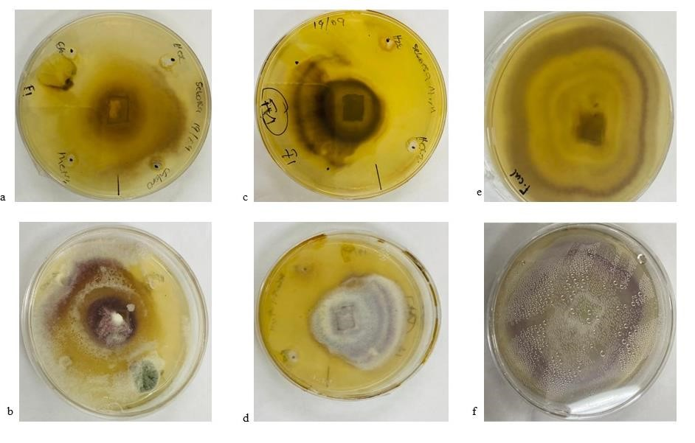
Figure 3.23: a) show the back side and b) show the front side of Fusarium culmorum agar plates tested against hexane, chloroform, ethyl acetate, and methanol sequence extracts. Figure 3.23 c) shows the back side and d shows the front side of Fusarium culmorum agar plates tested against sequence water extract and hexane sonicated extract. Figure 3.23 e) shows the back side and f) shows the front side show the Fusarium culmorum control.

The agar well method was used to observe any zones of inhibition for some of the homemade pest control extracts. In the agar well diffusion assay, neither the sequence extracts nor the sonicated extracts showed inhibition zones on any test microorganisms of Fusarium oxysporum and Fusarium verticillioidis. The results showed that all the sequence and the sonicated extracts are ineffective against Fusarium oxysporum and Fusarium verticillioidis, as they did not inhibit the growth of these microorganisms.

Results show that the growth of Fusarium culmorum is suppressed by the sequence water extract and sonicated hexane extract. The current study's phytochemical analyses and the annotated compounds revealed that homemade pest-control bioactive compounds such as saponins, terpenoids, alkaloids, flavonoids and amino acids have antimicrobial properties against various pathogens. The presence of bioactive compounds in the extracts is responsible for inhibiting the growth of pathogens. The extracts could stop the Fusarium culmorum from spreading all over the plants over 21 days.

Methanol and chloroform extracts had the best inhibition effect in broth dilution methods. On the other hand, these extracts did not show any inhibition effect against the tested Fusarium species in the agar diffusion method. The broth microdilution approach provided more definitive results because it revealed the MIC values at which these homemade pest control extracts inhibited the tested microorganisms. The study of Mahlo¹⁰¹ et al. produced similar results where methanol extracts showed the least overall efficacy against F. oxysporum.

It is known that bacterial growth is prevented using potato dextrose agar (PDA)¹⁰². Although the plates were inoculated with PDA, some were contaminated with bacteria from the extracts. These discoveries that occurred during the analysis show that further study is required—further study to analyse the effects of bacteria on plant growth and their role in the mixture. The study will help determine whether the bacteria and the bioactive compound work together to make the mixture effective.

A sample for a homemade pesticide was extracted in two methods and tests for pesticidal activity and other biological activities such as antifungal and antibacterial. Results show that sequential extraction is a better method; this was confirmed by higher activities found during biological activity and the annotated compounds by LC-MS/MS. Analysis showed that the mixture is a good pesticide as it showed the content of phenolic compounds, terpenoids, saponins and alkaloids, confirmed by phytochemicals, UV-Vis, FTIR and LC-MS/MS also annotated amino acids and fatty acids. Due to its ability to suppress the growth of antibacterial and antifungal organisms, homemade pest control is also a plant pathogen cure. The growth of Fusarium culmorum was suppressed by the sequence water extract and sonicated hexane extract. The extracts' ability to stop pathogen growth is due to their bioactive compounds.

3.7 Reference
- Bargah, R. K. Preliminary test of phytochemical screening of crude ethanolic and aqueous extract of Moringa pterygosperma Gaertn. J. Pharmacogn. Phytochem. 4, 7–9 (2015).
- Banu, K. S. & Cathrine, L. General techniques involved in phytochemical analysis. Int. J.
Adv. Res. Chem. Sci. 2, 25–32 (2015).
- Bennett, R. N., & Wallsgrove, R. M. Secondary metabolites in plant defence mechanisms. New Phytol. 127, 617–633 (1994).
- Balamurugan, V. & Velurajan, S. A guide to phytochemical analysis. IJARIIE 5, 236–245 (2019).
- Kovalikova, Z., Kubes, J. Skalicky, M., Kuchtickova, N. & Maskova, L., Tuma, J., Vachova, P., Hejnak, V. Changes in content of polyphenols and Ascorbic Acid in leaves of white cabbage after pest infestation. Molecules 24, 1–12 (2019).
- Lattanzio, V., Cardinali, A. & National, I. Role of polyphenols in the resistance mechanisms of plants against fungal pathogens and insects. in Phytochemistry : Advances in Research 23–67 (2006).
- War, A. R., Paulraj, M. G., Ahmad, T., Buhroo, A. A., Hussain, B., Ignacimuthu, S., & Sharma, H. C. Mechanisms of plant defense against insect herbivores. Plant Signals Behav. 7, 1–17 (2012).
- Mierziak, J., Kostyn, K. & Kulma, A. Flavonoids as important molecules of plant interactions with the environment. Molecules 19, 16240–16265 (2014).
- Cavoski, I., Caboni, P. & Miano, T. Natural Pesticides and Future Perspectives. in Pesticides in the Modern World - Pesticides Use and Management 169–189 (2011).
- Rattan, R. S. Mechanism of action of insecticidal secondary metabolites of plant origin.
Crop Prot. 29, 913–920 (2010).
- Plata-Rueda, A., Martínez, L. C., Rolim, G. S., Coelho, R. P. & Santos, M. H., Tavares, W. S., Zanuncio, J. C., Serrão, J. E. Insecticidal and repellent activities of Cymbopogon citratus (Poaceae) essential oil and its terpenoids (citral and geranyl acetate) against Ulomoides dermestoides. Crop Prot. 137, 1–8 (2020).
- Chaieb, I. Saponins as Insecticides: a Review. Tunis. J. Plant Prot. 5, 39–50 (2010).
- Shah, R. S., Shah, R. R., Pawar, R. B. & Gayakar, P. P. UV-Visible spectroscopy - A review. Int. J. Institutional Pharm. Life Sci. 5, 490–505 (2015).
- Bhanvase, B. & Barai, D. Stability of nanofluids. in Nanofluids for Heat and Mass Transfer 69–97 (2021).
- Da Silva, J. P., Vieira Ferreira, L. F., Osipov, I. & Ferreira Machado, I. Surface photochemistry of pesticides containing 4-chlorophenoxyl chromophore. J. Hazard. Mater.
179, 187–191 (2010).
- Tijjani, A., Bashir, K. A., Muhammad, A., Mohammed, I., Gambo, A., & Musa, H.
Biopesticides for pests control: A review. J. Biopestic. Agric. 3, 6–13 (2016).
- Manasa, G. Structural elucidation of terpenoids by spectroscopic techniques. J. Chem. Pharm. Sci. 1, 36–37 (2014).
- Venugopal, H., Sasikumar, K. G., Prathapachandra, R., & Anoop, M. Contemplating Macrotyloma uniflorum in traditional snake envenomation management practices through analysis on various solvents by a scheme of spectroscopic, phytochemical and chromatographical analysis. Int. J. Curr. Res. Biosci. Plant Biol. 7, 40–45 (2020).
- Upasani, S. M., Kotkar, H. M., Mendki, P. S. & Maheshwari, V. L. Partial characterization and insecticidal properties of Ricinus communis L foliage flavonoids. Pest Manag. Sci. 59, 1349–1354 (2003).
- Matsui, Y., Kobayashi, K., Masuda, H., Kigoshi, H., Sakurai, H., Kumagai, H., Akurai, Hidetoshi, S., & Hitomi, K. Quantitative analysis of saponins in a tea-leaf extract and their Antihypercholesterolemic activity. Biosci. Biotechnol. Biochem. 73, 1519–2009 (2014).
- Eldin, I., Elgailani, H. & Ishak, C. Y. Methods for extraction and charaterization of tannins from some Acacia. Pakistan J. Anal. Environ. Chem. 17, 43–49 (2016).
- Odeyemi, O. A review of the use of phytochemicals for insect pest control. African Plant Prot. 14, 1–7 (2008).
- Coates, J. Interpretation of Infrared spectra, a practical approach. Encycl. 91 Anal. Chem.
1–23 (2006).
- Urbano, M., Luque De Castro, M. D., Pérez, P. M., García-Olmo, J. & Gómez-Nieto, M. A. Ultraviolet-visible spectroscopy and pattern recognition methods for differentiation and classification of wines. Food Chem. 97, 166–175 (2006).
- Minatel, I. O., Borges, C. V., Ferreira, M. I., Alonzo, H. & Gomez, G. Phenolic compounds: Functional properties, impact of processing and bioavailability. in Phenolic Compounds - Biological Activity 1–24 (2017).
- Masek, A., Latos-Brozio, M., Chrzescijanska, E. & Podsedek, A. Polyphenolic profile and antioxidant activity of Juglans regia L. leaves and husk extracts. Forests 10, 1–14 (2019).
- Kareru, P. G., Keriko, J. M., Gachanja, A. N., & Kenji, G. M. Direct detection Of triterpenoid saponins in medicinal plants. African J. Tradit. Complement. Altern. Med. 5, 56–60 (2007).
- Ayaz, M., Junaid, M., Ullah, F., Sadiq, A., Ovais, M., Ahmad, W. & Ahmad, S., Zeb, A.
Chemical profiling, antimicrobial and insecticidal evaluations of Polygonum hydropiper L. BMC Complement. Altern. Med. 16, 1–14 (2016).
- Mashwani, Z., Ali, M., Khan, T. & Nadhman, A. Applications of plant terpenoids in the synthesis of colloidal silver nanoparticles. Adv. Colloid Interface Sci. 234, 132–141 (2016).
- Edris, A. E. Pharmaceutical and therapeutic potentials of essential oils and their individual volatile constituents: A review. Phyther. Res. 323, 308–323 (2007).
- Cox-Georgian, D., Ramadoss, N. & Dona, C., & Basu, C. Therapeutic and medicinal uses of terpenes. in Medicinal Plants: From Farm to Pharmacy 333–359 (2019).
- Schulz, H. & Baranska, M. Identification and quantification of valuable plant substances by IR and Raman spectroscopy. Vib. Spectrosc. 43, 13–25 (2007).
- Dhivya, S. M. & Kalaichelvi, K. Uv-Vis spectroscopic and Ftir analysis of Sarcostemma Brevistigma, Wight. Int. J. Curr. Pharm. Res. 9, 46–49 (2017).
- Wu, Y., Ren, D., Gao, C., Li, J., Du, B., Wang, Z., Qian, S. Recent advances for alkaloids as botanical pesticides for use in organic agriculture. Int. J. Pest Manag. 1, 1–12 (2021).
- Fitokimia, S., Ekstrak, F. & Daun, M. Phytochemical screening and Ftir spectroscopy on crude extract from Enhalus acoroides leaves. Mayaysian J. Anal. Sci. 24, 70–77 (2020).
- Mondal, M. H., Malik, S., Garain, A., Mandal, S., Saha, B. Extraction of natural surfactant saponin from soapnut (Sapindus mukorossi) and its utilization in the remediation of hexavalent chromium from contaminated water. Tenside, Surfactants, Deterg. 54, 519–529 (2017).
- Dutta, S., Mallick, M., Bertram, N., Greenwood, P. F., Mathews, R. P. Terpenoid composition and class of Tertiary resins from India. Int. J. Coal Geol. 80, 44–50 (2009).
- Wang, M., Carver, J.J., Phelan, V. V., Sanchez, L. M., Garg, N., Peng, Y., Nguyen, D. D., Watrous, J., Kapono, C. A., & Luzzatto-Knaan, T. Sharing and community curation of mass spectrometry data with Global Natural Products Social Molecular Networking. Nat. Biotechnol. 34, 828–837 (2016).
- Kalinski, J. C. J. & Waterworth, S. C., Noundou, X. S., Jiwaji, M., Parker-Nance, S., Krause, R. W.M., McPhail, K. L., Dorrington, R. A. Molecular networking reveals two distinct chemotypes in pyrroloiminoquinone-producing tsitsikamma favus sponges. Mar.
Drugs 17, 1–16 (2019).
- DEFRA. Risk reduction strategy and analysis of advantages and drawbacks for 4-tertoctylphenol. Department for environment, food and rural affairs (2008).
- Groshart, C. P., Okkerman, P. C., Wassenberg, W. B. A., & Pijnenburg, A. M. C. M.
Chemical study on alkylphenols. (2001).
- OSPAR Commision. Background document on octylphenol, hazardous substances series. 1-32 (2006).
- PubChem. 3,6,9,12,15,18,21,24,27,30-Decaoxadotriacontane- 1,32-diol. PubChem 1–20 (2005). Available at: https://pubchem.ncbi.nlm.nih.gov/compound/81260.
- Chirife, J., Herszage, L., Joseph, A., Bozzini, J. P., Leardini, N., & Kohn, E. S. In vitro antibacterial activity of concentrated polyethylene glycol 400 solutions. Antimicrob. Agents Chemother. 24, 409–412 (1983).
- Nalawade, T., Sogi, S. P. & Bhat, K. Bactericidal activity of propylene glycol, glycerine, polyethylene glycol 400, and polyethylene glycol 1000 against selected microorganisms. J. Int. Soc. Prev. Community Dent. 5, 114–119 (2015).
- Huang, Yi., Li, G., Hong, C., Zheng, X., Yu, H., & Zhang, Y. Potential of steroidal alkaloids in cancer: Perspective insight into structure–activity relationships. Front. Oncol. 11, 1–17 (2021).
- Yan, Y., Li, X., Zhang, C., Lv, L., Gao, B., & Li, M. Research progress on antibacterial activities and mechanisms of natural alkaloids: A review. Antibiotics 10, 1–30 (2021).
- Zhou, L. N., Ge, X. L., Dong, T. T., Gao, H. Y., & Sun, B. H. Antibacterial steroidal alkaloids from Holarrhena antidysenteriaca. Chin. J. Nat. Med. 15, 540–545 (2017).
- Fan, C., Yao, Z., Ye, M., Fu, L. & Zhu, G., Dai, Y., Yao, X. Fuziline alleviates isoproterenol-induced myocardial injury by inhibiting ROS-triggered endoplasmic reticulum stress via PERK/eIF2α/ATF4/Chop pathway. J. Cell. Mol. Med. 24, 1332–1344 (2020).
- Tiwari, P., Ramarao, P. & Ghosal, S. Insect repellent activity of diterpenoid alkaloids. Phyther. Res. 15, 170–171 (2001).
- Chen, X. H., Koumoutsi, A., Scholz, R., Schneider, K., Vater, J., Süssmuth, R., Piel, J. & Borriss, R. Genome analysis of Bacillus amyloliquefaciens FZB42 reveals its potential for biocontrol of plant pathogens. J. Biotechnol. 140, 27–37 (2009).
- Torres, M. J., Brandan, C. P., Sabaté, D. C., Petroselli, G. & Erra-Balsells, R., & Audisio,
M. C. Biological activity of the lipopeptide-producing Bacillus amyloliquefaciens
PGPBacCA1 on common bean Phaseolus vulgaris L. pathogens. Biol. Control 105, 93–99 (2017).
- Penha, R. O., Vandenberghe, L. P. S., Faulds, C., Soccol, V. T. & Soccol, C. R. Bacillus lipopeptides as powerful pest control agents for a more sustainable and healthy agriculture:
recent studies and innovations. Planta 251, 1–15 (2020).
- Gessler, N. N., Egorova, A. S. & Belozerskaya, T. A. Fungal anthraquinones. Appl.
Biochem. Microbiol. 49, 85–99 (2013).
- Anisha, C., Sachidanandan, P. & Radhakrishnan, E. K. Endophytic Paraconiothyrium sp. from Zingiber officinale Rosc. Displays broad-spectrum antimicrobial activity by production of Danthron. Curr. Microbiol. 75, 343–352 (2018).
- Awad, N. E., Kassem, H. A., Hamed, M. A., El-Naggar, M. A. A., & El-Feky, A. M. M. Bioassays guided isolation of compounds from Chaetomium globosum. J. Mycol. Med. 24, 1–8 (2014).
- PubChem. Danthron. PubChem 1–47 (2022). Available at: https://pubchem.ncbi.nlm.nih.gov/compound/2950#sec.
- Orjala, J., Erdelmeier, C. A. J., Wright, A. D., Rali, T., & Sticher, O. Five new prenylated p-hydroxybenzoic acid derivatives with antimicrobial and molluscicidal activity from Piper aduncum leaves. Planta Med. 59, 546–551 (1993).
- Kim, H. J., & Kwon, H. J. Synthesis and biological activity of fungal metabolite, 4Hydroxy-3-(3-Methyl-2’-Butenyl)- Benzoic acid. J. Microbiol. Biotechnol. 17, 543–545 (2007).
- Baumert, A., Kuzovkina, I. N. & Groger, D. Activation of Anthranilic acid and NMethylanthranilic acid by cell-free extracts from Ruta graveolens tissue cultures. Planta Med. 2, 125–127 (1985).
- Yeasmin, L., MacDougall, S. A. & Wagner, B. D. UV-A photochemistry of the pesticide azinphos-methyl: Generation of the highly fluorescent intermediate N-methylanthranilic acid. J. Photochem. Photobiol. A Chem. 204, 217–223 (2009).
- Schulz, R., Thiere, G. & Dabrowski, J. M. A combined microcosm and field approach to evaluate the aquatic toxicity of azinphosmethyl to stream communities. Environ. Toxicol. Chem. 21, 2172–2178 (2002).
- Gilman, J. D. & Bilyeu, K. D. Genes and alleles for quality traits on the soybean genetic/physical map. in Designing Soybeans for 21st Century Markets 67–96 (AOCS Press, 2010).
- Freese, E., Sheu, C. W., & Galliers, E. Function of lipophilic acids as antimicrobial food additives. Nature 241, 321–325 (1973).
- Sudha, T., Chidambarampillai, S. & Mohan, V. R. GC-MS analysis of bioactive components of aerial parts of Fluggea leucopyrus willd. (Euphorbiaceae). J. Appl. Pharm. Sci. 3, 126–130 (2013).
- Kim, B., Kim, H. M., Jin, C. H. & Kang, S., Kim, J., Jeon, Y. G., Park, K. Y., Lee, I., & Han, R. Composition and antioxidant activities of volatile coreopsis cultivars. Plants 9, 1– 9 (2020).
- Mohadjerani, M., Hosseinzadeh, R. & Hosseini, M. Chemical composition and antibacterial properties of essential oil and fatty acids of different parts of Ligularia persica Boiss.
Avicenna J. Phytomedicine 6, 357–365 (2016).
- Clements, J., Groves, R. L., Cava, J., Barry, C. C., Chapman, S., Olson, J. M. Conjugated linoleic acid as a novel insecticide targeting the agricultural pest Leptinotarsa decemlineata.
PLoS One 14, 1–14 (2019).
- Munné-bosch, S. & Alegre, L. The function of Tocopherols and Tocotrienols in plants. CRC. Crit. Rev. Plant Sci. 21, 31–57 (2002).
- Andrade, J. C., Morais-Braga, M. F. B., Guedes, G. M. M., Tintino, S. R., Freitas, M. A., Menezes, I. R. A., Coutinho, H. D. M. Enhancement of the antibiotic activity of aminoglycosides by alpha-tocopherol and other cholesterol derivates. Biomed. Pharmacother. 68, 1065–1069 (2014).
- Ghimire, B. K., Seong, E. S., Yu, C. Y., Kim, S. H. & Chung, I. M. α-tocopherol in a transgenic leaf could be correlated to the increased antimicrobial activity of transgenic C. lanceolata -tocopherol methyltransferase (γ-tmt) gene. South African J. Bot. 109, 25–33 (2017).
- Badshah L. S., Ullah. a., Ahmad. N., Almarhoon, Z. M., & Mabkhot, Y. Increasing the strength and production of Artemisinin and its derivatives. Molecules 23, 1–17 (2018).
- Chadwick, M., Trewin, H., Gawthrop, F., Wagstaff, C. Sesquiterpenoids Lactones: Benefits to plants and people. Int. J. Mol. Sci. 14, 12780–12805 (2013).
- Solujic, S., Sukdolak, S., Vokovic, N., Niciforovic, N., & Stanic, S. Chemical composition and biological activity of the acetone extract of Ambrosia artemisiifolia L. pollen. Serbian Chemical Soc. 73, 1039–1049 (2008).
- Hristova, Y., Wanner, J., Jirovetz, L., Stappen, I., Iliev, I., & Gochev, V. Chemical composition and antifungal activity of essential oil of Hyssopus officinalis L. from Bulgaria against clinical isolates of Candida species. Biotechnol. Biotechnol. Equip. 29, 592–601 (2015).
- Maity, A. & Mukherjee, I. Assessment of Iprovalicarb, a systemic fungicide in/on cabbage (Brassica oleracea var. Capitata). Bull. Environ. Contam. Toxicol. 83, 341–347 (2009).
- Kozioł, E. & Skalicka-Woźniak, K. Imperatorin–pharmacological meaning and analytical clues: profound investigation. Phytochem. Rev. 15, 627–649 (2016).
- Xu, G. H., Kim, J. A., Kim, S. Y., Ryu, J. C., Kim, Y. S., Jung, S. H., Kim, M. K., Lee, S.
H. Terpenoids and coumarins isolated from the fruits of Poncirus trifoliata. Chem. Pharm. Bull. 56, 839–842 (2008).
- Hadaček, F., Müller, C., Werner, A., Greger, H., Proksch, P. Analysis, isolation and insecticidal activity of linear furanocoumarins and other coumarin derivatives from Peucedanum (Apiaceae: Apioideae). J. Chem. Ecol. 20, 2035–2054 (1994).
- Khilya. V. P., & Aitmambetov, A. I. Synthetic and modified isoflavonoidsXII. Synthesis of homologs of 5,7-Dihydroxy- 3, 4- Methylenedioxyisoflavone. Chem. Nat. Compd. 30, 312– 315 (1994).
- Hadden, M. K., Galam, L., Gestwicki, J. E., Matts, R. L. & Blagg, B. S. J. Derrubone, an inhibitor of the Hsp90 protein folding machinery. J. Nat. Prod. 70, 2014–2018 (2007).
- Sadgrove, N. J., Oliveira, T. B., Khumalo, G. P., van Vuuren, S. F., van Wyk, B. E. Antimicrobial isoflavones and derivatives from erythrina (Fabaceae): Structure activity perspective (SAR & QSAR) on experimental and mined values against staphylococcus aureus. Antibiotics 9, 1–18 (2020).
- Heaton, J. C. & Jones, K. Microbial contamination of fruit and vegetables and the behaviour of enteropathogens in the phyllosphere: A review. J. Appl. Microbiol. 104, 613–626 (2008).
- Sivapalasingam, S., Friedman, C. R., Cohen, L., Tauxe, R. V. Fresh produce: A growing cause of outbreaks of foodborne illness in the United States, 1973 through 1997. J. Food Prot. 67, 2342–2353 (2004).
- Plotnikova, J. M., Rahme, L. G. & Ausubel, F. M. Pathogenesis of the human opportunistic pathogen Pseudomonas aeruginosa PA14 in Arabidopsis. Plant Physiol. 124, 1766–1774 (2000).
- Semenov, A. M., Kuprianov, A. A. & van Bruggen, A. H. C. Transfer of enteric pathogens to successive habitats as part of microbial cycles. Microb. Ecol. 60, 239–249 (2010).
- Sung H. J., Jiyoung L., Dong W. K., Dae H. L., Choong M. R., & Jeong, M. P. A human pathogenic bacterium Shigella proliferates in plants through adoption of type III effectors for shigellosis. in Plant, cell & environment 2962–2978 (2018).
- Wachtel, M. R., Whitehand, L. C. & Mandrell, R. E. Association of Escherichia coli O157:H7 with preharvest leaf lettuce upon exposure to contaminated irrigation water. J. Food Prot. 65, 18–25 (2002).
- Nuraskin, C. A., Marlina, M., Idroes, R., Soraya, C., Djufri, D. Antibacterial activity tests of n-hexane, ethyl acetate, and methanol leaves (Vitex) extract (pinnata) against streptococcus mutans. Open Access Maced. J. Med. Sci. 8, 181–184 (2020).
- Miller, S. I. Antibiotic resistance and regulation of the gram-negative bacterial outer membrane barrier by host innate immune molecules. Am. Soc. Microbiol. 7, 1–3 (2016).
- Exne, M., Bhattacharya, S., Christiansen, B., Gebel, J., Goroncy-Bermes, P., Hartemann, P., Heeg, P., Ilschner, C., Kramer, A., Larson, E., Merkens, W., Mielke, M., Oltmanns, P.,
Ross, B., Rotter, M., Ricarda, M., Trautmann, M. Antibiotic resistance: What is so special about multidrug-resistant Gram-negative bacteria? GMS Hyg. Infect. Control 12, 1–24 (2017).
- Ongena, M. & Jacques, P. Bacillus lipopeptides: versatile weapons for plant disease biocontrol. Trends Microbiol. 16, 115–125 (2008).
- Juhaniewicz-Dȩbińska, J., Lasek, R., Tymecka, D., Burdach, K. & Bartosik, D., Sȩk, S. Physicochemical and biological characterization of novel membrane-active cationic lipopeptides with antimicrobial properties. Langmuir 36, 12900–12910 (2020).
- Buwa, L. V. & Afolayan, A. J. Antimicrobial activity of some medicinal plants used for the treatment of tuberculosis in the Eastern Cape Province, South Africa. African J. Biotechnol. 8, 6683–6687 (2009).
- An, S. et al. USP18 protects against hepatic steatosis and insulin resistance through its deubiquitinating activity. Hepatology 66, 1866–1884 (2017).
- Nang, H. L. L., Choo, Y. M., Ma, A. N., Chuah, C. H. Extraction and identification of watersoluble compounds in palm-pressed fiber by SC-CO2 and GC-MS. Am. J. Environ. Sci. 3, 54–59 (2007).
- Yamaji, K., Ishimoto, H., Usui, N. & Mori, S. Organic acids and water-soluble phenolics produced by Paxillus sp. 60/92 together show antifungal activity against Pythium vexans under acidic culture conditions. Mycorrhiza 15, 17–23 (2005).
- Nawaz, H., Shad, M. A., Rehman, N., Andaleeb, H., Ullah, N. Effect of solvent polarity on extraction yield and antioxidant properties of phytochemicals from bean (Phaseolus vulgaris) seeds. Brazillian J. Pharm. Sci. 56, 1–9 (2015).
- Rabe, T. & Van Staden, J. Antibacterial activity of South African plants used for medicinal purposes. J. Ethnopharmacol. 56, 81–87 (1997).
- Early, R. Pathogen control in primary production: Crop foods. in Foodborne Pathogens: Hazards, Risk Analysis and Control: Second Edition 205–279 (Woodhead Publishing Limited, 2009).
- Mahlo, S. M., McGaw, L. J. & Eloff, J. N. Antifungal activity of leaf extracts from South African trees against plant pathogens. Crop Prot. 29, 1529–1533 (2010).
- Kheyrodin, H., Rajabi, L. & Kianian, & M. K. Study of Potato Dextrose Agar (PDA). in Journal Biology Innovation 7, 511–520 (2018).

4 Experimental

4.1 Introduction
This experimental section describes the materials, procedures and techniques used during extraction, analysis and characterization. In addition, it includes the phytochemical screening of the crude extracts and bioassay activity testing.

4.2 Materials

4.2.1 Chemicals
The chemical reagents used were purchased from Merck Group South Africa. The solvents used for the extraction procedure were hexane (C₆H₁₄), chloroform (CHCl₃), ethyl acetate (C₄H₈O₂₎, methanol (CH₃OH) and distilled water (H₂O). The chemicals used for phytochemical testing included concentrated hydrochloric acid (HCl) and sulphuric acid (H₂SO₄₎, ferric chloride (FeCl₃), acetone, mercuric potassium iodide (K₂Hgl₄), dimethyl sulfoxide (DMSO) and methanol (CH₃OH). Formic acid (CH₂O₂) and acetonitrile (MeCN) were used as mobile phases in the LCMS/MS analysis. For bioassay activity testing, barium chloride (BaCl₂), Mueller-Hinton (MH) broth, neomycin, sterile silane (containing 9,0 g/l of sodium chloride, NaCl), potato dextrose agar (PDA) and p-iodonitrotetrazolium violet (INT), amphotericin B were used.

4.2.2 Sample collection
Mr Lekgotla Joseph Moshweshwe supplied the homemade pest remedy from Hasethunya village in the Maloti-a-Phofung municipality, Thabo Mofutsanyane district in the Free State province of South Africa. The homemade mixtures were in a liquid state (solution), and 4 litres of the mixture were collected and stored at room temperature until they were analysed.

4.3 Preparation for extraction

4.3.1 Liquid-liquid extraction
“Liquid-liquid extraction is a method for extracting a solute from a solution in a certain solvent using another solvent”¹. The second liquid (solvent) in liquid-liquid extraction has to be immiscible or partially miscible, with the feed added to the mixture’s solutes for phase separation to occur². The mixture was sequentially extracted, as described in Figure 4.1. Extraction was done by mixing 2 litres of the homemade pesticides with 2 litres of hexane. After 24 hours of stirring (Figure 4.2 (a)), phase separation occurred, causing the two immiscible liquids to re-separate Figure 4.2 (b)). The organic hexane layer was evaporated on a rotary evaporator (Figure 4.2 (c)), and the extracted product was left overnight in the fume hood to dry. The extraction of chloroform, ethyl acetate, methanol, and water were done similarly to the previous step. The prepared extracts were stored at room temperature until they were used for further analysis. Finally, the extracts were, hexane (0.0614g), chloroform (0.7085g), ethyl acetate (0.1682g), methanol (0.3832g) and water (0.2676).

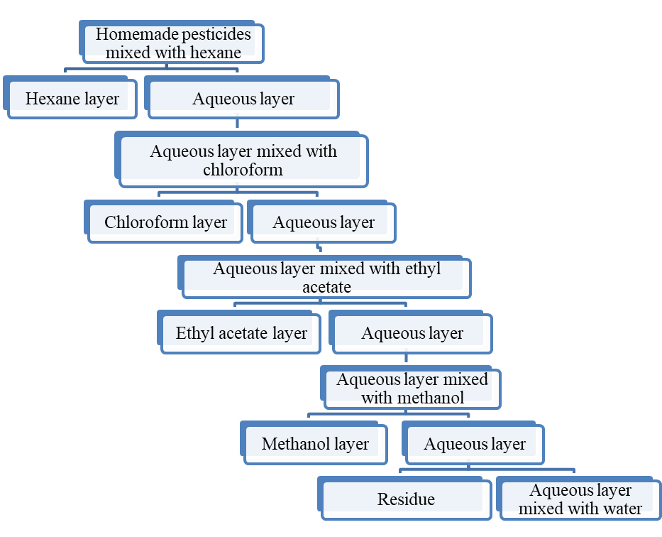
Figure 4.1: Sequence extraction of homemade pest control mixture flow diagram

a)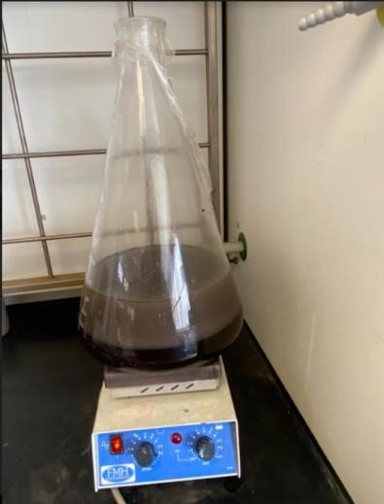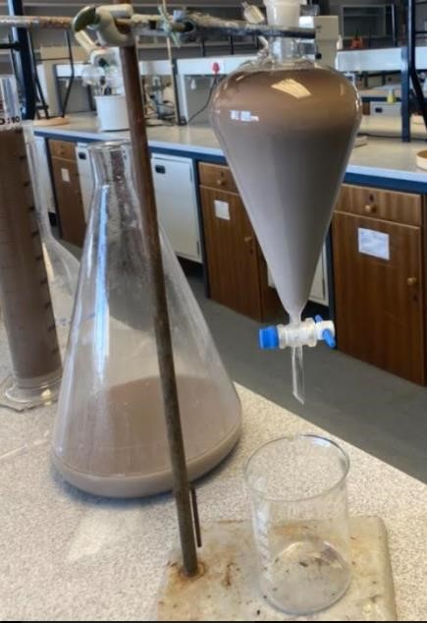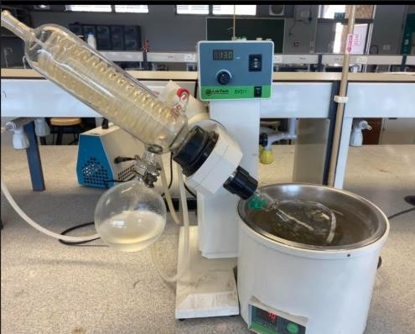
b)
c)
Figure 4.2: Homemade pest control extraction process. This figure illustrates how the sequence extract was done. (a) The extraction was done by adding an organic solvent to the homemade pest control and stirring for 24 hours. (b) After 24 hours of stirring, phase separation occurred, causing the two immiscible liquids to separate. (c) The organic hexane layer was evaporated on a rotary evaporator.

4.3.2 Ultrasonication extraction
As shown in Figure 4.3, the 2 litres of the homemade mixture were sequentially sonicated with 2 litres of various solvents (hexane, chloroform, ethyl acetate, methanol, and water). The mixtures were sonicated for 15 minutes (frequency 25-40 Hz) at ambient temperature³. The layers were separated using a separatory funnel (Figure 4.2 (b)) and evaporated to dryness using a rotary evaporator (Figure 4.2 (c)); the extracts were left overnight to dry in the fume hood. The extracts were also weighed and stored at room temperature until the subsequent use. Finally, yield of the extracts were, hexane (0.1981g), chloroform (0.0449g), ethyl acetate (0.0756g), methanol (0.1587g) and water (0.02841g).

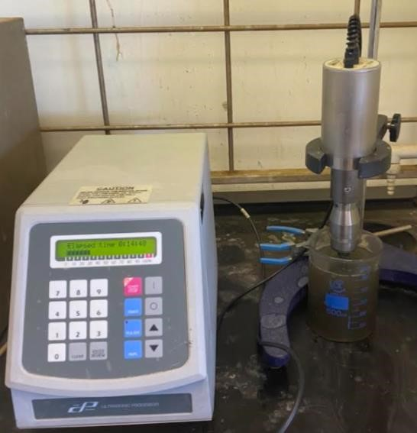
Figure 4.3: Extraction of homemade pest control using ultra sonication

4.4 Phytochemical test
The purpose of this test was to detect and analyse the phytochemicals in the homemade mixture. The filtrate from different solvent extracts was used to test for phytochemicals. The preliminary phytochemical testing was accomplished using standard procedures described by Bargah⁴ to identify the various constituents. Therefore, analyzing these chemical constituents helped to determine various phytoconstituents in the homemade mixture.

Identification of alkaloids Mayer's test
About 3 drops of potassium mercuric iodide solution were added to 2 ml of filtrate. A yellow orange precipitate established the presence of alkaloids.

Identification of phenolic compounds
Test for ferric chloride: two drops of 5% ferric chloride were added to 2 ml of the filtrate. A greenblack precipitate detected phenolic chemicals.

Identification of terpenoids
Sulphuric acid test: 2 ml of chloroform were added to 5 ml of extract and gently shaken. 3ml of sulphuric acid was poured gently along the side of the test tube. A reddish-brown ring indicated the presence of terpenes.

Identification of saponins
A 5 ml extract filtrate was diluted with 5 ml of distilled water for the foam test, which involved vigorous shaking for 5 minutes. The presence of saponins was later confirmed by a lingering froth that rose above the mixture.

4.5 Spectroscopic analysis

4.5.1 Ultraviolent spectrometer (UV-Vis)
UV-Vis was used to study the photoconstituents⁵ present in the homemade mixture extracts by examining their characteristic absorption region. The UV-Vis spectra of samples were recorded on a Lambda 25 high-performance single monochromatic UV-Vis spectrophotometer. All extracts analyses were performed in the 200-700 nm wavelength range using the crude extracts dissolved in distilled water and sonicated for 3 minutes.

4.5.2 Fourier-transform infrared spectroscopy (FTIR)
FTIR analysis uses infrared light to scan the samples to identify organic, inorganic, and polymeric components⁶. A Perkin Elmer Spectrum 100 infrared spectrometer was used at Rhodes University to conduct FTIR spectroscopy to identify the functional groups in the chemical mixtures. Four scans examined samples in an attenuated total reflectance (ATR) detector spanning a 650-4000 cm⁻¹ wavenumber range.

4.5.3 Liquid Chromatography with tandem mass spectrometry (LC-MS/MS)
Metabolites analysis of organic extract was performed on LC-QTOF-MS/MS using a Dionex Ultimate 3000 HPLC system equipped with a Fortis Speed core column (2.6 µm, 3 x 100 mm) connected to a Bruker Compact QTOF mass spectrometer. An mg of different crude extracts was dissolved in 1ml of HPLC grade methanol, sonicated for 5 minutes and then filtered through 0.22 µm polyvinylidene fluoride membrane syringe filters into a 1 ml auto-sampler vial. The solvents used in the mobile phase (A, B) consisted of H₂O + 0.01% formic acid (A) and MeCN + 0.01% formic acid (B) with a flow rate of 0.3 mL/ min employed. The mobile phase gradient started with a 5 min hold at 30% B. From minutes 5 to 15, the gradient was ramped from 60% B to 80% B, followed by a 5 min hold at 80% B. The mobile phase was set at 100% B from minutes 20-25. Injection volumes were set to 5 µl. The MS source parameters for positive mode were set as follows: End plate offset 500 V, capillary voltage 4500 V, nebuliser pressure 3.0 bar, dry gas flow 9.0 L/min, and dry temperature 210 °C. In addition, the three most intense precursor ions were selected to record the ms² spectrum with a data-dependent recording mode and collision energy of 10 eV with a transfer time of 120 µs.

4.6 Biological testing

4.6.1 Antibacterial activity
On Mueller Hinton (MH) agar plates, Pseudomonas aeruginosa, Escherichia coli, Klebsiella pneumoniae, Staphylococcus aureus, Staphylococcus epidermidis, Bacillus cereus, Bacillus pumilus, Enterococcus feacalis, Proteus vulgaris, Shigella flexneri were kept alive. A single bacterial colony was cultivated for the bioassay in about 2 ml of MH broth for 24 hours. The mixture was diluted with MH broth (1 ml bacteria: 99 ml broth) to determine the bacteria's log phase when the test began.

The microplate method of Eloff⁷ was used to test homemade pest control extracts for antibacterial activity. Dried homemade pest control extracts were dissolved at 50 mg/ml using extracting solvents. Each well received 100 µl of bacterial culture after each extract had been serially diluted two-fold to 0.38 g/ml from its initial concentration of 12.5 mg/ml in 96-well microplates. The extract-free wells, neomycin, and antibiotic controls were used as controls. The microplates were then incubated for the following 24 hours at 37 °C. A 40 µl of p-Iodonitrotetrazolium violet (INT) solution was added to each microliter plate well to measure bacterial growth. The plates were then incubated for 30 minutes at 37 °C. The minimum inhibitory concentration (MIC) value that prevented bacterial growth was noted. Each extract underwent three similar tests.

4.6.2 Antifungal activity
Test for microorganisms included Candida albicans, Candida. Vulgaris and Trichophyton mucoides. A modified broth microdilution assay was carried out as suggested in liturature^{8,9}. About 400 µl of fungal cultures growing for 24 hours were mixed with 4 ml sterile saline. To match the absorbance of a 0.5 McFarland standard solution, the absorbance was measured at 530 nm and corrected with sterile saline. A 1:1000 dilution of the produced stock fungal cultures in nutrient broth was made. Organic solvent extracts were dissolved in dimethyl sulfoxide (DMSO), whereas dried residues from water extracts were dissolved in sterile distilled water. 100 mg/ml was used to dissolve each extracts.

A 96-well microplate was filled with about 100 µl of nutritional broth. While organic solvent extracts were evaluated at 6.25 mg/ml and diluted two-fold to 0.049 mg/ml, water extracts were examined at 25 mg/ml at first and serially diluted to 0.195 mg/ml. For each extract, three duplicates were created. Then, 100 µl of fungal stock culture was added to each well. Amphotericin B served as a positive control. The plates were parafilm-wrapped and kept at 33 °C overnight for incubation. INT dissolved in water was introduced to each well of the microplates as a fungus growth indicator, and the microplates were then incubated for 30 minutes. Then, the MIC values were noted.

4.6.3 Agar well diffusion antifungal Assay
The study used three fungal strains: Fusarium culmorum, Fusarium oxysporum, and Fusarium verticillioidis, to test antifungal activities.

The antifungal activity of various solvent extracts was screened using the Agar well diffusion method with modification, as shown by Daoud¹⁰ et al. The Petri dish holding the inoculum was then filled with Potato Dextrose Agar (PDA) and thoroughly mixed. After solidifying, wells were drilled into agar plates containing inoculums using pipette tips. A small piece of fungal culture was placed in the center of a clean Petri dish. Then, 50 µl of each extract was added to the appropriate wells. The plates were placed in the fume hood for 30 minutes to allow the extracts to diffuse properly into the agar. Following that, the plates were incubated for 48 hours at 37 °C and stored in the incubator for 21 days. Antimicrobial activity was found by monitoring the inhibition zone that developed following the incubation time. Distilled water was used as a negative control.

4.7 References
- Jeki, B. Extraction. in Food Process Engineering and Technology 289–310 (2018).
- Seppälä, P., Dahal, R. & Moriam, K. Downstream process: Liquid-liquid extraction. Degree Program. Chem. Technol. 1, 1–11 (2016).
- Tor, A., Aydin, M. E. & Özcan, S. Ultrasonic solvent ex traction of organochlorine pesticides from soil. Anal. Chim. Acta 559, 173–180 (2006).
- Bargah, R. K. Preliminary test of phytochemical screening of crude ethanolic and aqueous extract of Moringa pterygosperma Gaertn. J. Pharmacogn. Phytochem. 4, 7–9 (2015).
- Jain, P. K., Soni, A., Jain, P. & Bhawsar, J. Phytochemical analysis of Mentha spicata plant extract using UV-VIS, FTIR and GC/MS technique. J. Chem. Pharm. Res. 8, 1–6 (2016).
- Titus, D., Samuel, J. J. E. & Roopan, S. M. Nanoparticle characterisation techniques. in Green Synthesis, Characterisation and Applications of Nanoparticles 303–319 (2019).
- Eloff, J. N. A sensitive and quick microplate method to determine the minimal inhibitory concentration of plant extracts for bacteria. Planta Med. 64, 711–713 (1998).
- Espinel-Ingroff, A., Dawson, K., Pfaller, M., Anaissie, E., Breslin, B., Dixon, D., Fothergill, A. & Paetznick, V., Peter, J., Rinaldi, M., Walsh, T. Comparative and collaborative evaluation of standardisation of antifungal susceptibility testing for filamentous fungi. Antimicrob. Agents Chemother. 39, 314–319 (1995).
- Buwa, L. V. & Van Staden, J. Antibacterial and antifungal activity of traditional medicinal plants used against venereal diseases in South Africa. J. Ethnopharmacol. 103, 139–142 (2006).
- Daoud, A., Malika, D., Bakari, S., Hfaiedh, N., Mnafgui, K., Kadri, A. & Gharsallah, N. Assessment of polyphenol composition, antioxidant and antimicrobial properties of various extracts of Date Palm Pollen (DPP) from two Tunisian cultivars. Arab. J. Chem. 12, 3075–
3086 (2019).

5 Conclusion and Future Work

5.1 Conclusion
Most small farmers in undeveloped areas like the Afromontane region cannot afford synthetic pesticides due to high costs. Small-scale farmers often rely on homemade pesticides, which seem to work because they can inhibit pathogen growth and repel insects. Therefore, this study extracted and analysed a homemade pesticide and found it efficient against insects and plant infections because they contain beneficial phytochemicals. The aim and objectives of the study were to collect and extract homemade pest control and test the biological activity of the different extracts. Also, to characterise the extracts using Ultraviolet-visible spectroscopy (UV-Vis), Fourier transforms infrared spectroscopy (FTIR), and liquid chromatography-tandem mass spectrometry (LC-MS/MS) in order to determine the constituents which may be responsible for the biological actictivity.

The sequential solvent extraction and ultrasonication methods were used to extract chemical compounds present in the homemade pesticides. Moreover, phytochemical screening was used to determine the different classes of compounds which are found in those pesticides. Microbial bioassay testing was used to determine the minimum inhibitory concentration of bacterial and fungal organisms against the homemade mixture created by the farmer. Furthermore, UV-Vis, FTIR, and LC-MS/MS were utilised to annotate the chemical compounds in the mixture. The phytochemical test revealed that the phytochemicals are present in the mixture. According to various research, phytochemicals tested have insecticidal properties and can be used to treat plant diseases^{1,2,3,4,5}. Phytochemicals such as phenolic compounds (flavonoids), alkaloids, terpenoids, and saponins were detected.

The phytoconstituents included in the homemade mixture extracts were investigated using UVVis by examining their characteristic absorption zone. According to the literature, all phytoconstituents detected above have insecticidal properties a specific UV-VIS spectral

band^{6,7,8,9}. The compounds absorbance transition was determined to lie between 220 and 330 nm. The phytochemical test results and UV-Vis spectrum absorption confirmed the presence of secondary metabolites that can be used as biopesticides. In addition, the functional groups such as O-H, C-H, C=O, C=C aromatic stretching, and C-O and C-H bending were identified using FTIR spectroscopy. These functional groups can be used to detect the different phytochemical compounds confirmed. The phytochemical test, absorption on the UV/Vis spectrum, and FTIR results revealed the active compounds that can be used as biopesticides.

LC-MS/MS reproduced the components of the analysed homemade pest treatment extracts based on collision-induced dissociation spectra. The method annotated the metabolites of homemade pesticides using a Global Natural Product Social Molecular Networking (GNPS) platform. A Cytoscape constructed chemical networks based on similarities between fragmentation spectra, and a GNPS carried out database searches of repository spectra to find potential compound matches. The molecular network of homemade pesticides shows five clusters with characteristics similar to phenols, alkaloids, fatty acids, and isoflavonoids. According to the literature, the compounds annotated had antimicrobial properties, while others had insecticidal activity. Ethyl acetate extract, chloroform sequence extract, and sonicated hexane extracted more compounds than the other solvents. A summary of LC-MS/MS annotated compounds with the biological properties is shown on Table 5.1.

Table 5.1: A summary of LC-MS/MS annotated compounds with the biological properties
Cluster | Annotated compounds | Identified  Chromophores | Biological activity
1 | P-tert-octylphenol heptaglycol ether, p-tert-octylphenol nonaglycol ether, p-tert-octylphenol hexaglycol ether, p-tert-octylphenol decaglycol ether and undecaethylene glycol. | Flavonoids | Antimacrobial activity  Pesticidal activity
2 | imperialine, putative orn, lipopeptides, fuziline, megestrol-17-acetate, danthron and protoporphyrin IX | Alkaloids  Flavonoids | Antimicrobial activity  Pesticidal activity
3 | 3-methyladenine, 4-hydroxy-3-(3methylbut-2-enyl) benzoic acid, Nmethylanthranilic acid, tributyl phosphate, and 1-[3-methoxy-4-  [(2S,3R,4S,5S,6R)-3,4,5-trihydroxy-6[[(2R,3R,4R,5R,6S)-3,4,5-trihydroxy-6methyloxan-2-yl] oxymethyl] oxan-2-yl] oxyphenyl] ethanone | Alkaloids  Amino acids | Antimicrobial activity  Pesticidal activity
4 | linolenic acid, linolenic acid ethyl ester, conjugated linoleic acid, alpha-tocopherol, ipravalicard, and (2S)1-[2-[(3-hydroxy-1-adamantyl) amino]-  1-oxoethyl]-2-pyrrolidinecarbonitrile | Fatty acids  Alkaloids | Antimicrobial activity  Pesticidal activity
5 | Imperatorin, derrustone | Flavonoids | Antimicrobial activity  Pesticidal activity

The biological activity of the homemade pest control was analysed using the microdilution method and agar diffusion method. Microdilution assay screened homemade pest control extracts' antibacterial and antifungal activity against selected bacteria and fungi microorganisms. The bioassay findings showed that the extracts of the homemade mixture tested had inhibitory effects against both gram-negative, gram-positive bacterial and fungal strains. The most active extracts for antibacterial and antifungal screening were chloroform and methanol from both extraction methods. In contrast, water, hexane and ethyl acetate extracts had activity against gram-positive microorganisms and poor activity against the test fungal strains.

The zones of inhibition for some of the homemade pest control extracts were examined using the agar well method to test the antifungal activity against selected Fusarium species. The results indicated that neither the sequencial nor the sonicated extracts successfully prevented the growth of Fusarium oxysporum and Fusarium verticillioidis. The sequencial water extract and sonicated hexane extract inhibited Fusarium culmorum growth. As a result, the homemade pest control employed in this study could be explored as a low-cost plant pathogens control.

In conclusion, these findings support the small-scale farmer's claims, homemade pesticide is effective against insect pests and plant pathogens. The results indicate that the mixture contains compounds that are effective against plant pathogens and capable of killing insect pests. Continued study on homemade pest control will open doorways for the invention of developing new low price and environmentally friendly biopesticides. The small-scale farmers can rely on their indigenous homemade pest control mixtures, which seems to work because they are satisfied with their crops' yield and quality. In addition, there is a need to look for affordable and environmentally friendly pesticides to document this indigenous knowledge and assess the effectiveness of these already available pesticides that small-scale farmers are already producing and using. The studies of homemade pest control will motivate the implementation and production of these mixtures on larger scales by industries or pesticide manufacturers to promote organic farming that will benefit human beings and protect the organisms found in the environment.

5.2 Recommendations
Farmers typically employ water as an extractant since it is readily available and it is cheaper to use. The water extracts in this investigation had limited activity, and other researchers have also reported that water is an ineffective extractor for extracting the active components from plants. Organic solvent extracts have been found to have more reliable antibacterial properties. Organic solvents are too expensive, and small-scale farmers cannot afford to purchase these solvents for preparations for homemade pest control. The farmers should instead devise other options such as planting sugarcane among other sources to extract ethanol from them. However, a study must be conducted first whereby the mixture will be prepared using sugarcane ethanol and then sprayed on the crops. After that, the soil and the plants must be analysed to assess the effects on the solution.

5.3 Future Perspectives
The following objectives are planned for future studies. The GNPS showed that the extracts contain about 73 compounds and some of them are novel compounds, therefore more research is needed on isolating and purifying the new bioactive component. A further study to assess the effectiveness of the homemade pesticides towards garden pests by looking at the avoidance behaviours of earthworms and garden snails towards the pesticides. The study will help to determine the toxicity of homemade pest control. To date the shelf-life of the homemade pest control is not known, thus a kinetic study is required to estimate the half-life of the extracts.

5.4 References
- Bennett, R. N., & Wallsgrove, R. M. Secondary metabolites in plant defence mechanisms. New Phytol. 127, 617–633 (1994).
- Balamurugan, V. & Velurajan, S. A guide to phytochemical analysis. IJARIIE 5, 236–245 (2019).
- Lattanzio, V., Cardinali, A. & National, I. Role of polyphenols in the resistance mechanisms of plants against fungal pathogens and insects. in Phytochemistry: Advances in Research 23–67 (2006).
- Mierziak, J., Kostyn, K. & Kulma, A. Flavonoids as important molecules of plant interactions with the environment. Molecules 19, 16240–16265 (2014).
- Chaieb, I. Saponins as Insecticides: A Review. Tunis. J. Plant Prot. 5, 39–50 (2010).
- Manasa, G. Structural elucidation of terpenoids by spectroscopic techniques. J. Chem. Pharm. Sci. 1, 36–37 (2014).
- Upasani, S. M., Kotkar, H. M., Mendki, P. S. & Maheshwari, V. L. Partial characterization and insecticidal properties of Ricinus communis L foliage flavonoids. Pest Manag. Sci. 59, 1349–1354 (2003).
- Eldin, I., Elgailani, H. & Ishak, C. Y. Methods for extraction and charaterization of tannins from some Acacia. Pakistan J. Anal. Environ. Chem. 17, 43–49 (2016).
- Odeyemi, O. A review of the use of phytochemicals for insect pest control. African Plant Prot. 14, 1–7 (2008).

Appendix

LC-MS/MS

2-Linoleoyl-1-palmitoyl-sn-glycero-3-phosphoethanolamine
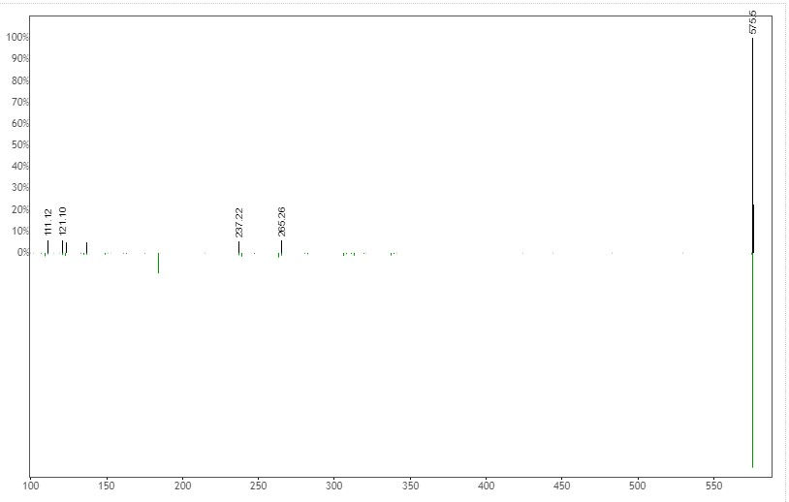

Pheophorbide A

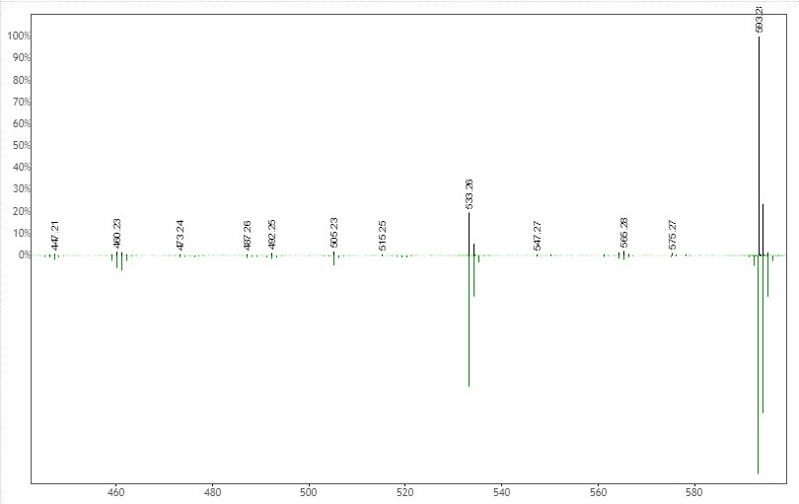

AC1L1X1Z
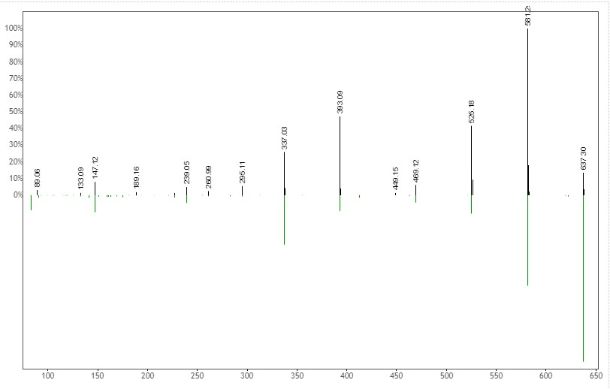

PE-DAG (14:0/16:1)
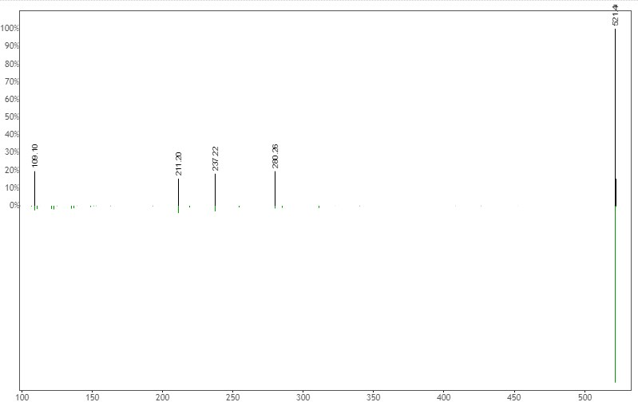

99
Molecular networking clusters with novel compounds

a.
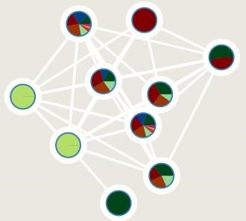
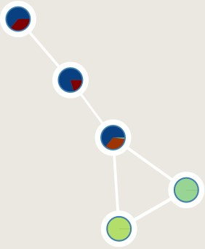
b.

c. 

Antifungal agar well diffusion method Plates that shows bacterial growth from the extracts

