Plate 2e: COSY of 4’,4’’-Di-O-acetyl-3”-methoxynyasol, CDCl₃ (298 K)

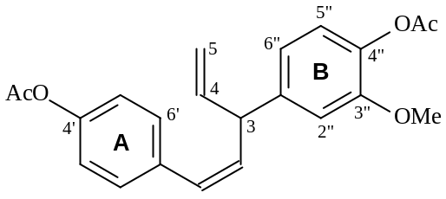
(92)



